|  |
| --- |
| **Il-Ħin *The Time*** |

|  |  |  |
| --- | --- | --- |
| **il-ħin tal-ġurnata**  ***the time of the day*** | **a.m. or p.m?** | **it-tislima**  ***the greeting*** |
| Filgħodu  *morning* | ta’ filgħodu  ex.: 8 a.m. =  it-tmienja ta’ filgħodu  *eight o’clock* | Bonġu / L-għodwa t-tajba  *Good morning!* |
| nofsinhar  *noon* |  | Saħħa! |
| waranofsinhar  *afternoon* | ta’ waranofsinhar  ex.: 3 p.m. =  it-tlieta ta’ waranofsinhar  *three o’clock* | Il-waranofsinhar it-tajjeb!  *Good afternoon!* |
| filgħaxija  *evening = 6 p.m. – 10 p.m.* | ta’ filgħaxija  ex.: 6 p.m. = is-sitta ta’ filgħaxija  *six o’clock* | Bonswa! / Il-lejla t-tajba!  *Good evening!* |
| billejl  *night = 10 p.m. onwards* | ta’ billejl  ex.: 11 p.m. = il-ħdax ta’ billejl | Bonswa! / Il-lejl it-tajjeb!  *Good night!* |

➢ **Kif ngħidu l-ħin bil-Malti.**

*How to tell the time in Maltese*

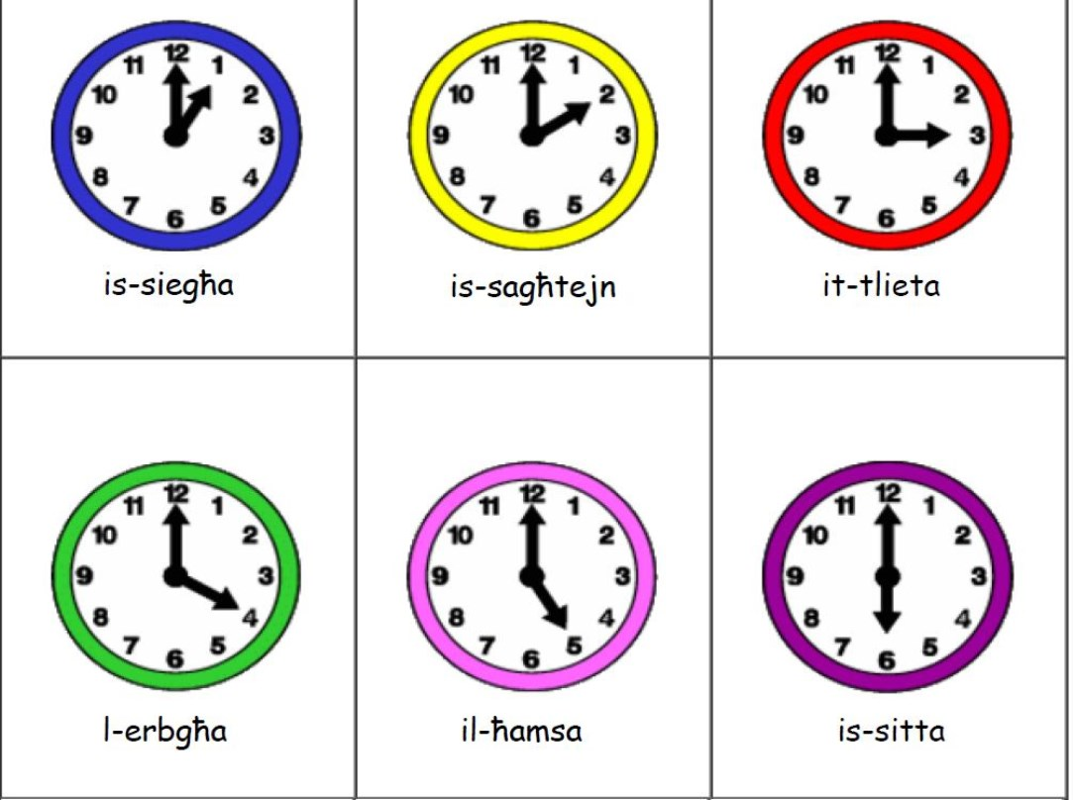

four

*one o’clock*

*four o’clock*

*two o’clock*

*five o’clock*

*three o’clock*

*six o’clock*

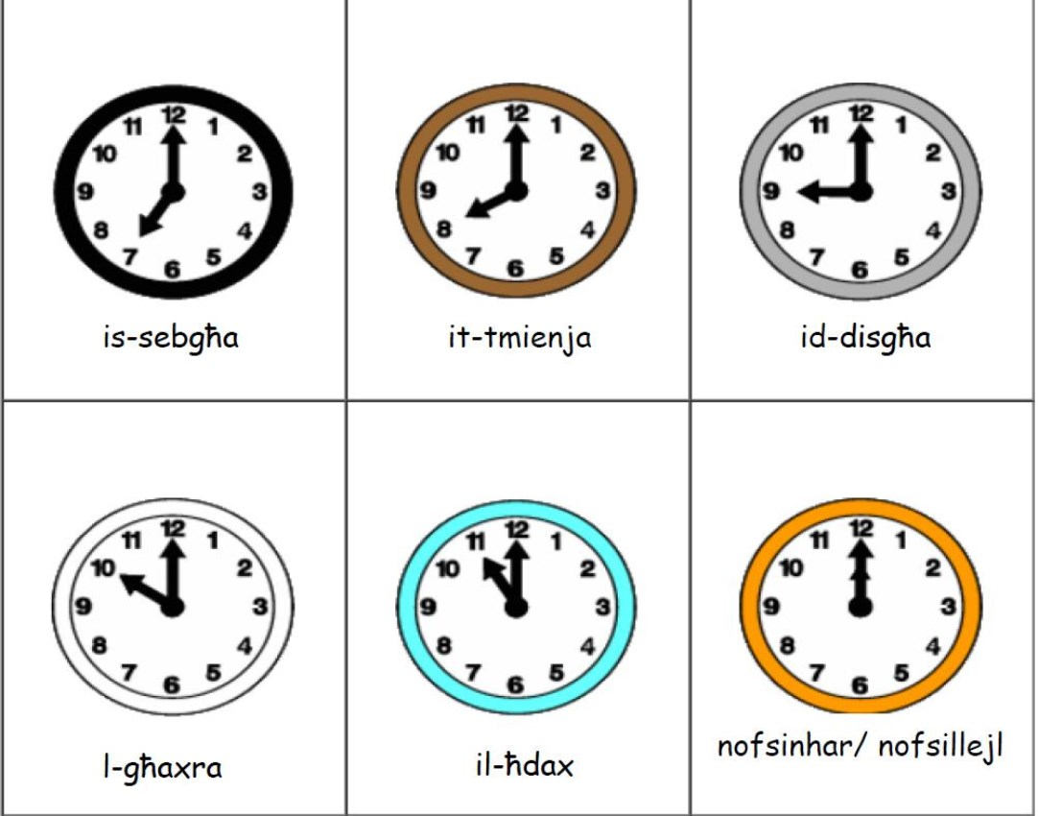

*seven o’clock*

*ten o’clock*

*eight o’clock*

*eleven o’clock*

*nine o’clock*

*twelve o’clock*

*noon / midnight*

u ħamsa

u għaxra

u kwart

u għoxrin

u nofs neqsin ħamsa

u nofs

u nofs u ħamsa

neqsin għoxrin

neqsin kwart

neqsin għaxra

neqsin ħamsa

*5 minutes past*

*10 minutes past*

*quarter past*

*20 minutes past*

*25 minutes past*

*half past*

*35 minutes past*

*20 minutes to*

*quarter to*

*10 minutes to*

*5 minutes to*

➢ **Important expressions / questions:**

X’ħin hu?

Fi x’ħin ġej it-tabib?

It-tabib ġej…

Fi x’ħin ġej in-ners?

In-ners ġej …

Fi x’ħin se nieklu?

X’ħin sar?

Fi x’ħin ġejja t-tabiba?

It-tabiba ġejja …

Fi x’ħin ġejja n-ners?

In-ners ġejja …

X’ħin ġej l-ikel?

*What time is it?*

*At what time is the doctor coming?*

*The doctor is coming at …*

*At what time is the nurse coming?*

*The nurse is coming at …*

*At what time are we eating? At what time is the food coming?*

➢ **Qabbel il-ħin miktub bil-Malti f’kolonna A ma’dak ekwivalenti f’kolonna B.**

*Match the time in Maltese in column A to the equivalent in column B.*

**Kolonna A** **Kolonna B**

1 Is-siegħa u ħamsa 2:10

2 Is-siegħa neqsin ħamsa 1:50

3 Is-sagħtejn u għaxra 8:30

4 Is-sagħtejn neqsin għaxra 6:20

5 Is-sagħtejn u nofs 5:25

6 It-tmienja u nofs 6:10

7 Il-ħamsa neqsin kwart 12:55

8 Is-sitta u għoxrin 2:30

9 Is-sitta u għaxra 4:45

10 Il-ħamsa u nofs neqsin ħamsa 1:05

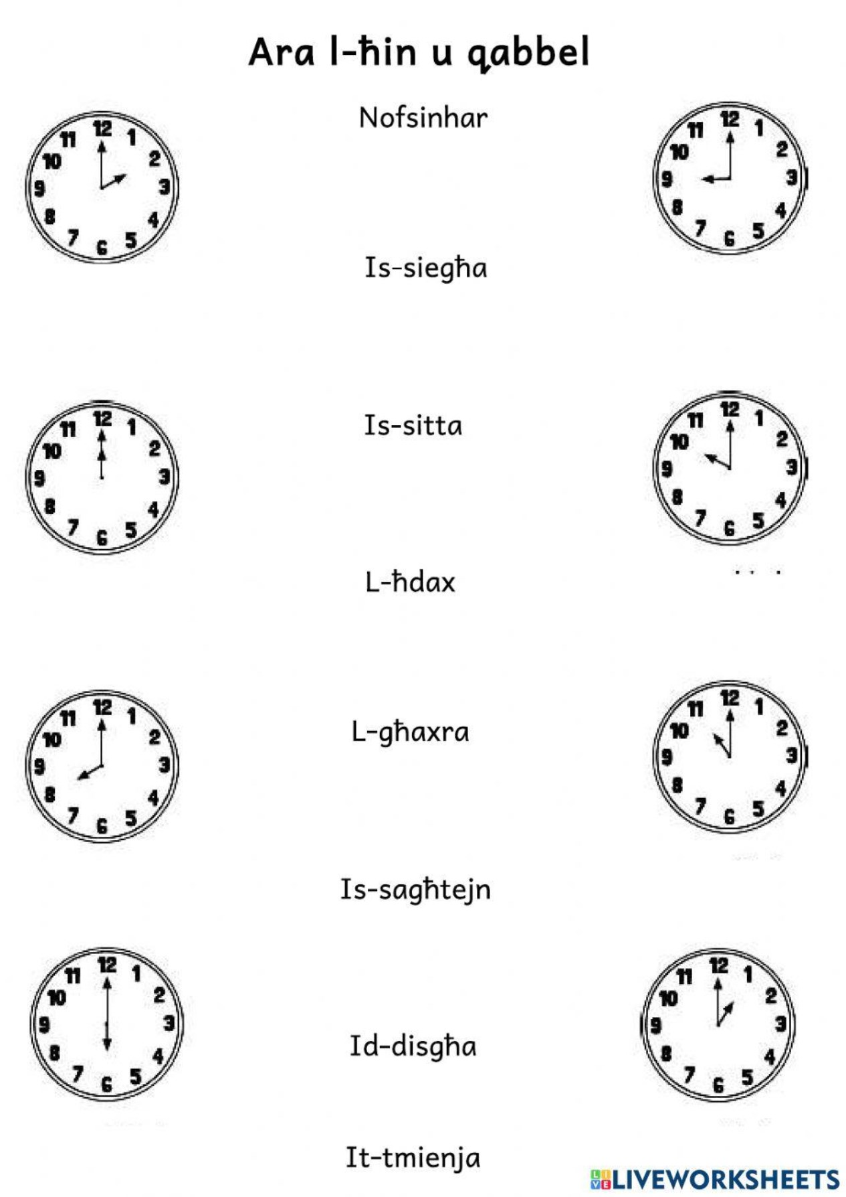

n

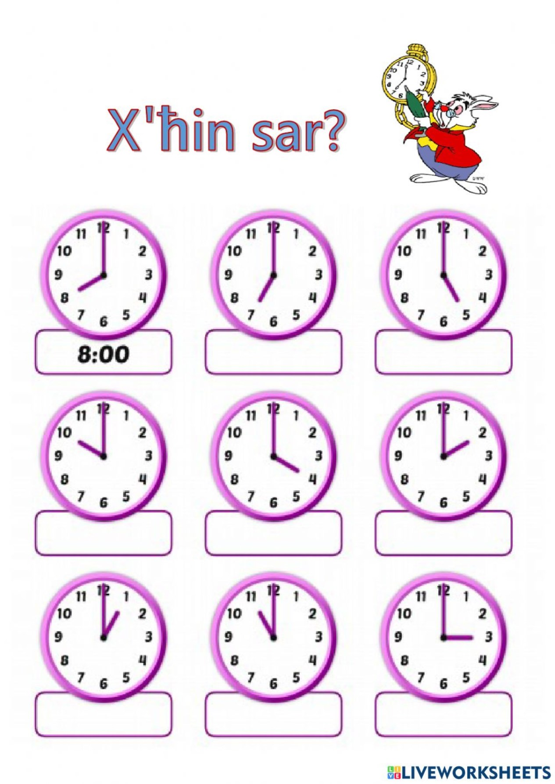

What time is it?

am pm pm

am am pm

pm pm am

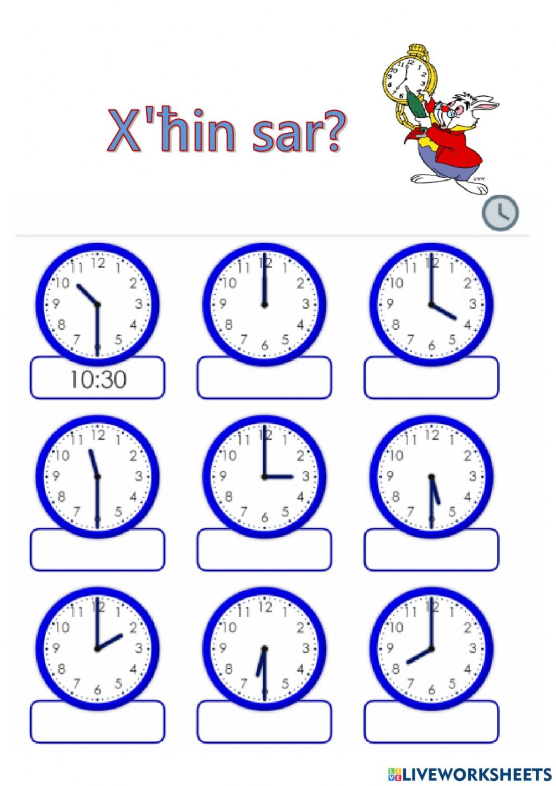

am pm am

pm pm pm

pm am pm

➢ **Ħares lejn l-istampa t’hawn taħt u ikteb il-ħin li qed juri kull arloġġ.**

*Look at the picture below and write down the time that each clock shows.*

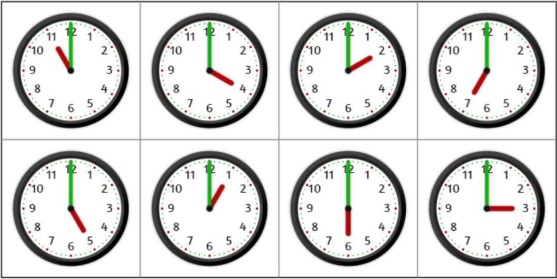

|  |  |
| --- | --- |
| 1 |  |
| 2 |  |
| 3 |  |
| 4 |  |
| 5 |  |
| 6 |  |
| 7 |  |
| 8 |  |

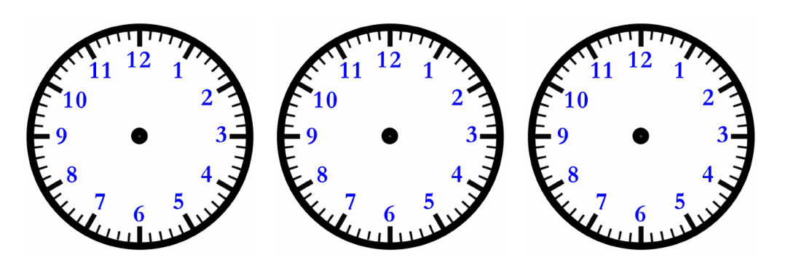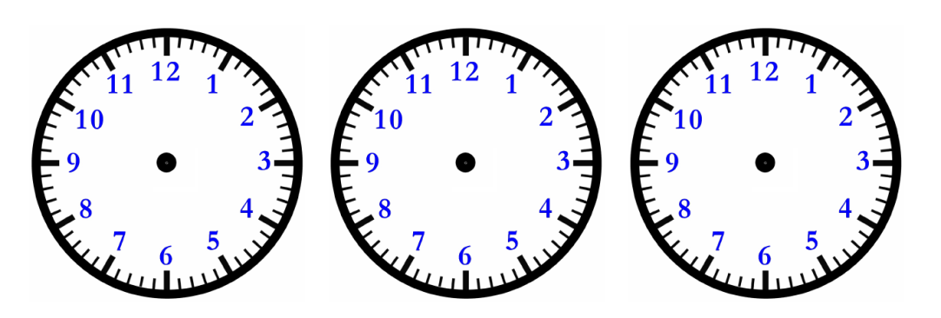➢ **Isma’l-ħinijiet li qed taqra l-għalliema u ħażżeż il-ħin fuq l-arloġġi t’hawn taħt.**

*Listen to the times being read by the teacher and illustrate them on the clocks below.*

**Questions for reflection**

1. What are the Maltese equivalents of: a) quarter past; b) quarter to; c) half past; d) twenty minutes to; and e) twenty minutes past?
2. What do we say in Maltese instead of **a.m.** and **p.m.**?
3. How do you indicate **midnight** and **noon** in Maltese?

➢ **Isma’dan id-djalogu u ipprattikah f’pari.**

*Listen to this dialogue and practise it in pairs.*

1) **Djalogu 1**: X’ħin hu? (*What time is it?)*

Kelliem 1:

Kelliem 2:

Kelliem 1:

Kelliem 2:

Bonġu. Tista’ tgħidli x’ħin hu jekk jogħġbok?

Bonġu. Bħalissa id-disgħa u kwart.

Grazzi ħafna.

M’hemmx imniex.

2) **Djalogu 2**: X’ħin jibda l-eżami? (*What time does the examination start?)*

Kelliem 1:

Kelliem 2:

Kelliem 1:

Kelliem 2:

Il-waranofsinhar it-tajjeb. Tista’ jekk jogħġbok tgħidli x’ħin

jibda l-eżami?

Il-waranofsinhar it-tajjeb lilek ukoll. L-eżami jibda fil-ħamsa.

Grazzi ħafna.

M’hemmx imniex.

3) **Djalogu 3**: X’ħin ġej l-għalliem? (*What time is the teacher coming?)*

Kelliem 1:

Kelliem 2:

Kelliem 1:

Kelliem 2:

Kelliem 1:

Kelliem 2:

Bonġu Sara.

Bonġu Kevin.

Tista’ tgħidli x’ħin ġej l-għalliem illum?

L-għalliem ġej fid-disgħa ta’ filgħodu għax mar l-isptar.

Tajjeb ħafna. Grazzi.

M’hemmx imniex.

_ _ _ _ _

➢ **Aqra dan id-djalogu u wieġeb il-mistoqsijiet dwaru.**

*Read the following dialogue and answer the questions.*

a) Djalogu bejn għalliem, is-Sur Borg u l-istudent John (*a dialogue between a teacher and John the student)*

**Sur Borg**: Bonġu John. Kif inti illum?

**John**: Bonġu Sur Borg. Jien tajjeb grazzi u inti?

**Sur Borg**: Jien tajjeb ukoll. Nixtieq inkellmek dwar it-test tal-Malti li kellna. Ma tantx mort tajjeb.

**John**: Għaliex, Sur Borg?

**Sur Borg**: Inti ġibt ħamsin marka minn mija. Stajt mort aħjar.

**John**: Fejn mort ħażin?

**Sur Borg**: Ma tantx fhimt il-pronomi personali u l-artiklu.

**John**: Kif nista’ mmur tajjeb darba oħra?.

**Sur Borg**: Trid tistudja aktar.

**b) Immarka jekk hux *Veru* jew *Falz.***

*Mark* ***true*** *or* ***false****.*

**Veru Falz**

1 Is-Sur Borg huwa għalliem.

2 John kellu test tal-Ingliż.

3 John mar tajjeb fit-test li kellu.

4 John irid jistudja aktar biex jgħaddi mit-test.

5 L-għalliem ra lil John filgħaxija.