|  |
| --- |
| **In-Numri *The Numbers*** |
|  |
| In-numri jistgħu jkunu: *The numbers can be:*   * kardinali = juru kwantita’ > *cardinal = indicate a quantity* * ordinali = juru l-pożizzjoni jew l-ordni > *ordinal = indicate a position/*   *order* |

**Mill-1 sal 10**

*1 to 10*

0 - żero

1 – wieħed

2 – tnejn

3 – tlieta

4 – erbgħa

5 – ħamsa

6 – sitta

7 – sebgħa

8 – tmienja

9 – disgħa

10 – għaxra

**Mill-11 sad-19**

*11 to 19*

11 - ħdax

12 – tnax

13 - tlettax

14 - erbatax

15 - ħmistax

16 – sittax

17 – sbatax

18 - tmintax

19 – dsatax

**L-għaxriet**

*Counting in tens*

20 – għoxrin

30 – tletin

40 – erbgħin

50 – ħamsin

60 – sittin

70 – sebgħin

80 – tmenin

90 - disgħin

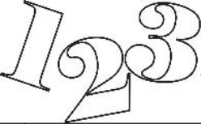100 – mija

* **In-numri minn 21 sa 100**

*Numbers from 21 up to 100*

**NOTA**: Biex ngħidu n-numri ikbar minn 20 bil-Malti, irridu nibdew min-numru ta’ wara.

*To say the numbers greater than 20 in Maltese, we have to start from the number at the end.*

eżempju: 21 – wieħed (1) u għoxrin (20)

34 – erbgħa (4) u tletin (30)

58 – tmienja (8) u ħamsin (50)

97 -- sebgħa (7) u disgħin (70)

**Taħriġ A:** Qabbel il-kelma mal-figura.

*Match the word with the number.*

tlieta u tletin □ □ 68

sitta u sebgħin □ □ 33

disgħa u għoxrin □ □ 84

erbgħa u tmenin □ □ 42

tmienja u sittin □ □ 76

tnejn u erbgħin □ □ 29

**Taħriġ B:** Ikteb kliem flok numri.

*Write the numbers in words.*

|  |  |
| --- | --- |
| **24** |  |
| **68** |  |
| **90** |  |
| **27** |  |
| **58** |  |
| **36** |  |
| **42** |  |
| **77** |  |
| **84** |  |
| **15** |  |

**Taħriġ Ċ:** Ikteb numri flok kliem.

*Write the words in numbers.*

disgħa u tmenin

sitta u sittin

sebgħin

tlieta u għoxrin

erbgħa u ħamsin

disgħa u tletin

sebgħa u erbgħin

wieħed u sebgħin

disgħa u tmenin

dsatax

* In-numri kardinali minn 11 sa 19 iżidu **-il** magħhom meta jiġu qabel in-nom.

*Cardinal numbers from 11 to 19 are attached the hyphenated* ***-il*** *before the noun.*

eżempju: Għandi ħdax**-il** sena.

Għandi tnax**-il** libsa.

* Wara n-numri minn 11 sa 99, in-nom ikun fis-singular.

*Numbers from 11 to 99 are followed by a singular noun.*

eżempju: Għandi sitta u tletin **ktieb.**

Għandi ħamsa u ħamsin **sena**.

**Taħriġ D:** Agħżel il-kelma t-tajba.

*Choose the correct word.*

1. Ix-xufier għandu tnejn u tletin (sena, snin).

2. It-tifel tiegħi għandu wieħed u għoxrin (pasta, pasti).

3. Toni xtara (tlettax, tlettax-il) (flokk, flokkijiet).

4. Mario ġab (ħdax-il, ħdax) (siġġijiet, siġġu).

5. Maria għandha tnejn u għoxrin (lapes, lapsijiet).

6. Fil-kamra hemm tnax-il (student, studenti).

7. Id-dentist ħadem (ħdax-il, ħdax) siegħa.

**Taħriġ E:** Ikteb in-numri fi kliem u agħżel in-nom it-tajjeb.

*Write the numbers in words and choose the correct noun.*

1. **20** siġġu / siġġijiet

2. **30** kotba / ktieb

3. **90** sufanijiet / sufan

4. **21** kuġin / kuġini

5. **32** fenek / fniek

___________________________________________

___________________________________________ ___________________________________________ ___________________________________________

___________________________________________

6. **43** raġel / irġiel ___________________________________________

7. **54** bdiewa / bidwi ___________________________________________

* **In-Numri Ordinali**

*Ordinal Numbers*

In-numri ordinali juru l-pożizzjoni jew l-ordni. Dawn jinkitbu bl-artiklu.

*Ordinal numbers show a rank or order. They are used with the definite article.*

1 *first*

2 *second*

3 *third*

4 *fourth*

5 *fifth*

6 *sixth*

7 *seventh*

8 *eighth*

9 *ninth*

10 *tenth*

|  |
| --- |
| **Taħriġ F:** L-istudenti kellhom eżami u ġabu dawn il-marki. Ħares lejn it-tabella u imla l-vojt.  *The students had an exam and obtained these marks. Look at*  *the table and fill in the blanks.*  ***NOTE:*** *Along with the definite article, here we are adding the preposition*  ***fi + article (example: fi + l- = fil-ħames)***  ***NOTE: ġiet = feminine***  ***ġie = masculine.*** |

l-ewwel

it-tieni

it-tielet

ir-raba’

il-ħames

is-sitt

is-seba’

it-tmien

id-disa’

l-għaxar

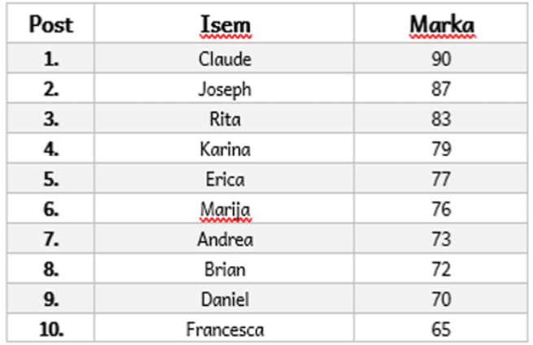

1. Daniel ġie fid-disa’ post.

2. Karina ġiet _____________________ post.

3. Marija ġiet ___________________ post.

4. Rita ġiet __________________ post.

5. Erica ġiet ___________________________________________ .

6. Joseph _____________________________________________ .

7. Andrea _____________________________________________ .

8. Francesca __________________________________________ .

9. Claude _____________________________________________ .

10. Brian ___________________________________________.

* Il-bqija tan-numri ordinali, mill-11 sad-99 jinkitbu bħala numri

kardinali + l-artiklu.

*The rest of the ordinal numbers, from 11 to 99, are written as cardinal numbers + definite article.*

eżempju: Fil-kompetizzjoni ġejt il-wieħed u għoxrin.

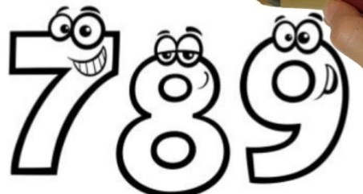 *In the competition, I placed twenty-first.*

Fl-eżami ġejt it-tlieta u tletin.

*In the exam, I placed thirty-third.*

**Taħriġ Ġ:** Imla l-vojt bin-numri ordinali kif indikat fil-parentesi.

*Fill in the blanks with ordinal numbers as indicated in the brackets.*

Eżempju: **Is-segħin** (70) ktieb.

1. ___________________________________ (40) telefonata. (*call)*

2. ___________________________________ (25) diska. *(song)*

3. ___________________________________ (60) par żarbun. *(pair of shoes)*

4. ____________________________________(55) student. *(student)*

5. ____________________________________(38) karozza. *(car)*

6. ____________________________________(80) pitazz. *(copybook)*

7. ____________________________________(20) platt. *(dinner plate)*

8. ____________________________________(44) lapes. *(pencil)*

9. ____________________________________ (88) flokk. *(T-shirt)*

10. ____________________________________ (27) pajjiż. *(country)*

11. ____________________________________ (66) tazza. *(drinking glass)*

