|  |
| --- |
| **Pronomi Demonstrattivi *Demonstrative Pronouns*** |

* Il-**pronomi demonstrattivi** joqogħdu flok in-nomi. Huma jippuntaw lejn xi ħaġa fil-qrib jew fil-bogħod.

*Demonstrative pronouns are used instead of nouns. They “point out” to something close to or far away from the speaker.*

* Il-pronomi demonstrattivi huma:

*The demonstrative pronouns are:*

**Singular Plural**

dan *(this* *– masculine) ______* dawn *(these – any gender)*

din *(this – feminine)*

dak *(that – masculine)* ______ dawk *(those – any gender)*

dik  *(that – feminine)*

**Taħriġ A: Imla l-pronom demonstrattiv dan jew din.**

_______ qattus iswed u abjad *(black and white).*

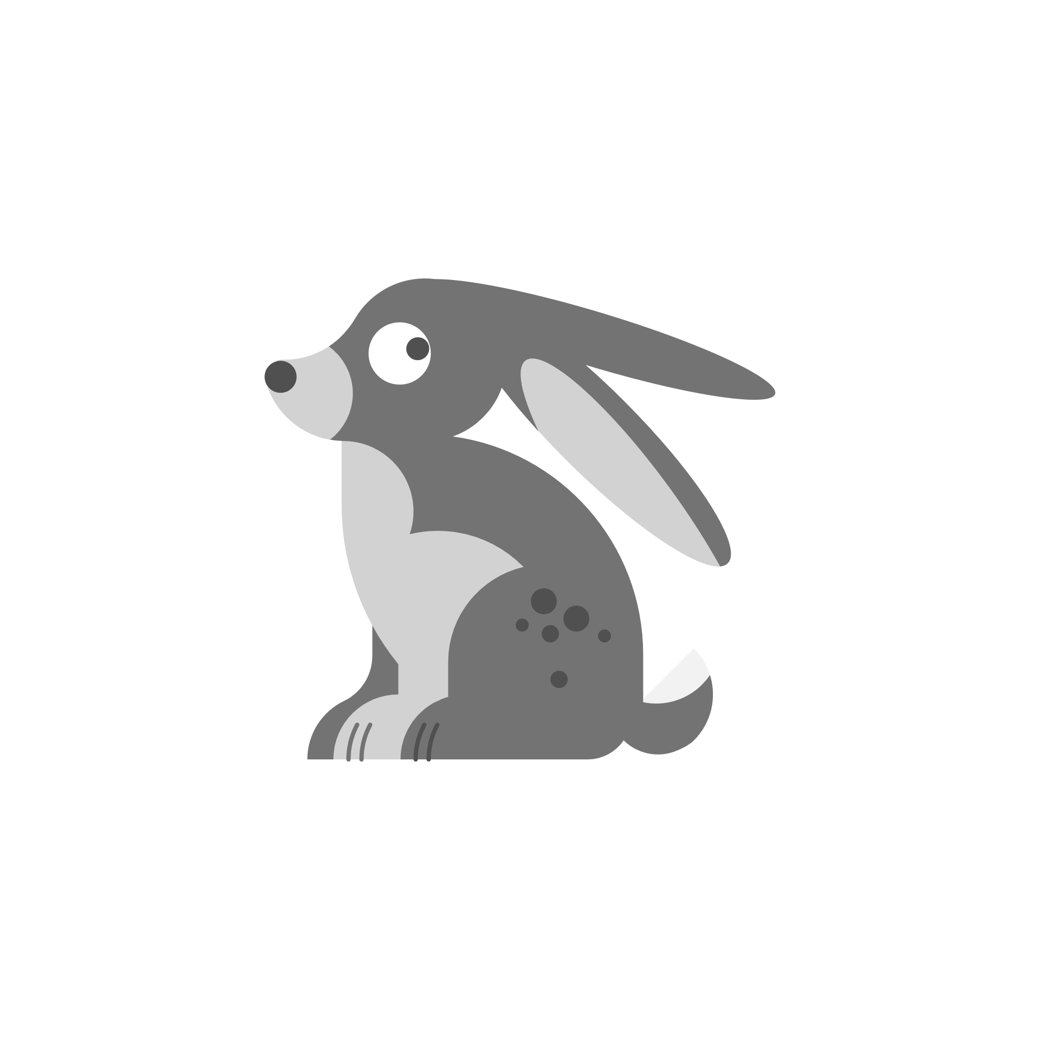 _______ qattusa sabiħa.

_______ fenek iswed u abjad.

** _______ fenka żgħira *(small).*

*____*___ umbrella sewda u bajda.

______ umbrella ġdida *(new)*.

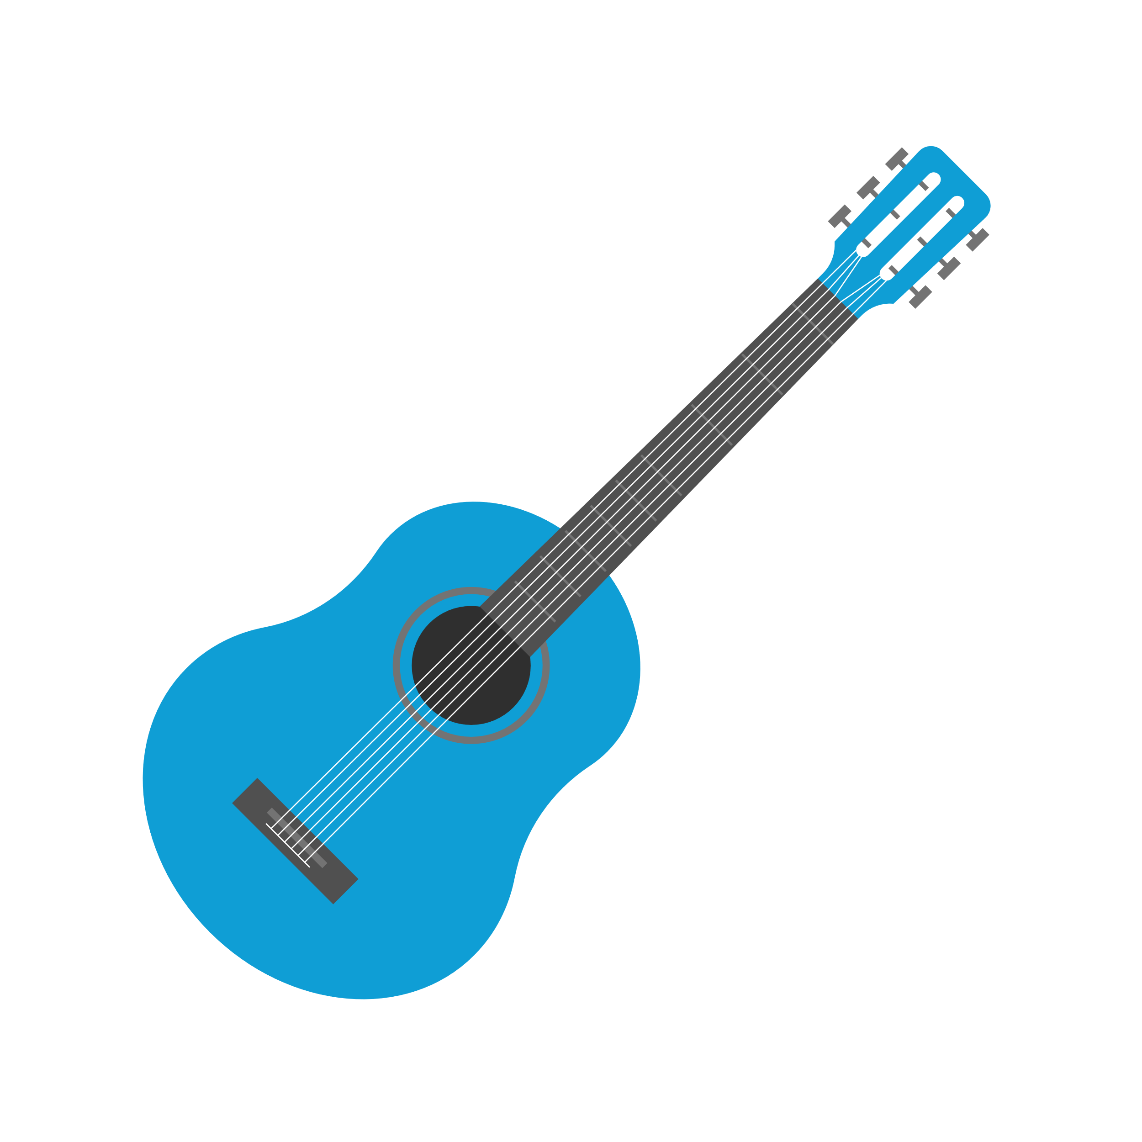

_______ kitarra ġdida u sewda.

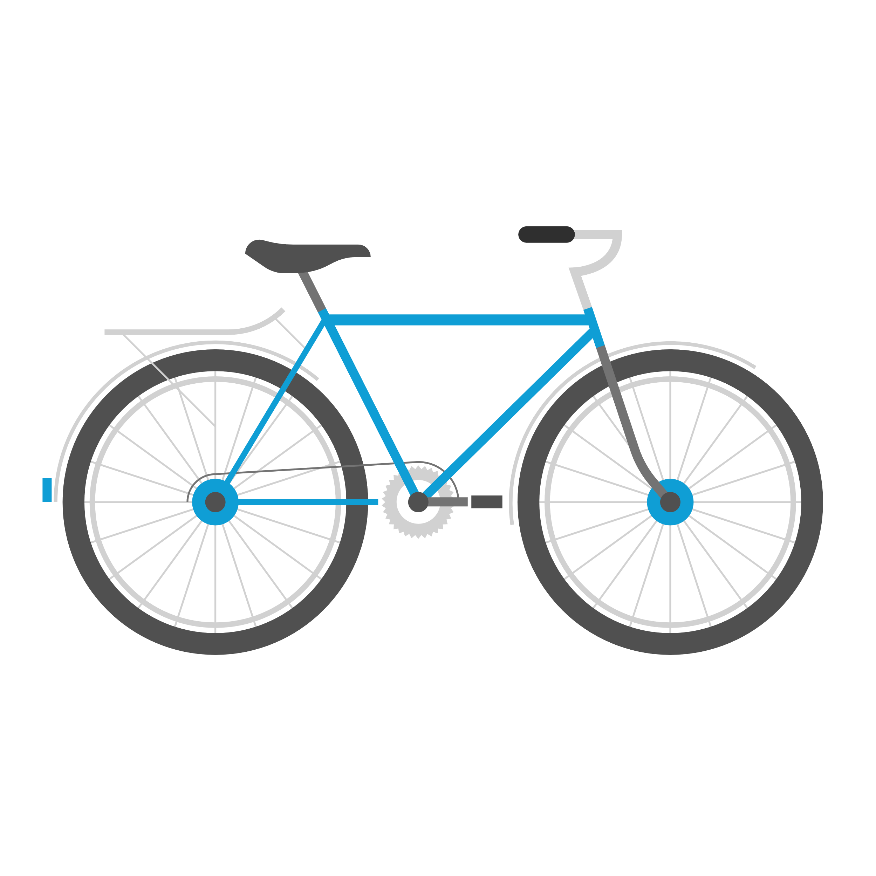 Jien għandi _______ il-kitarra.

_______ rota ġdida.

Ravi għandu _______ rota ġdida u sewda.

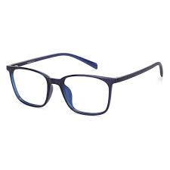 _______ in-nuċċali żgħir u ġdid.

Jien għandi ________ _______________________

**Taħriġ B: Imla dak, dik, dawk + xi kliem ieħor *(+ other words)*.**

_________ il-fliexken tal-ħġieġ.

Jien għandi _________ ______________________

_________ il-kejk tajjeb.

Jien inħobb _________ _______________

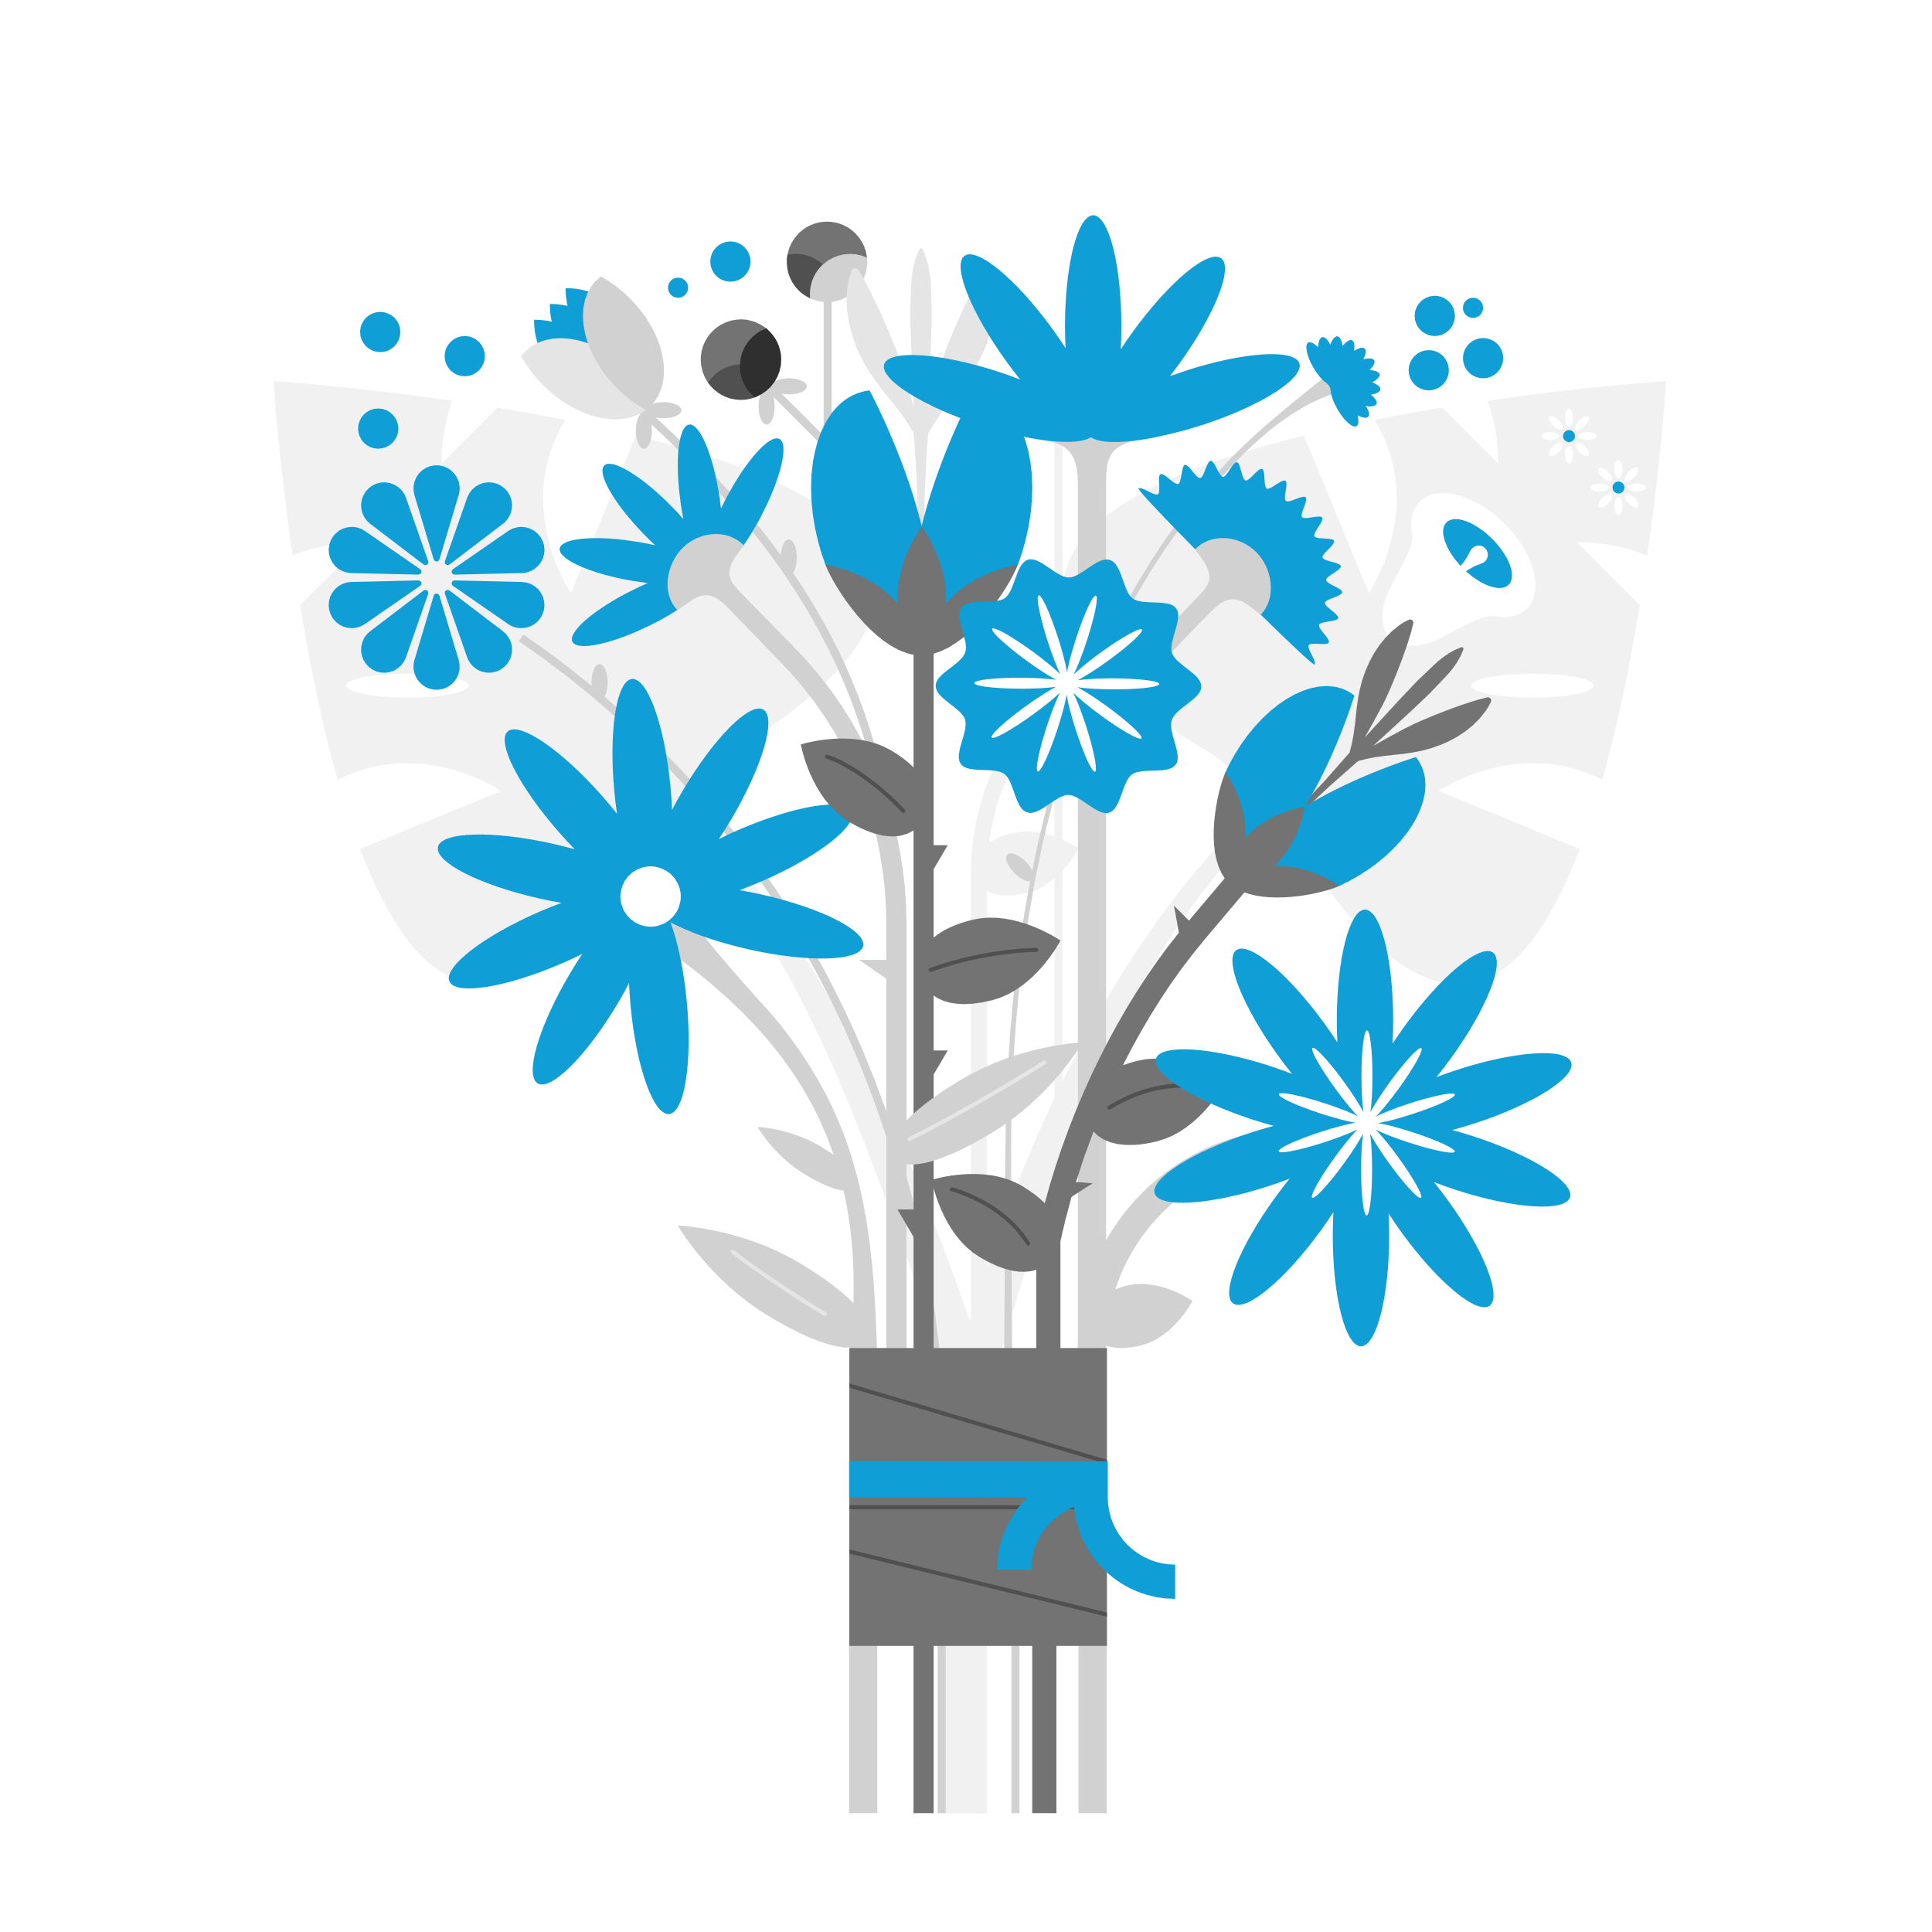

_________ il-fjuri sbieħ u friski *(nice and fresh).*

Jien xtrajt *(bought)* ______________________________________

 __________ ____ kotba ġodda.

__________ ____ _____________________ u ___________.

Jien ___________________________________________________.



___________ ___ rigali __________ u _________________

Jien xtrajt __________ ____ rigali minn *(from)* __________

ħanut (shop).

Jien _______________________________________________

 ___________ il- frott frisk.

___________ ______________________ u tajjeb.

Jien xtrajt_________________________________________

minn ____________________.

**Taħriġ Ċ: Ikteb dak li tisma’.**

1. ________________________________________________________
2. ________________________________________________________
3. ________________________________________________________
4. ________________________________________________________
5. ________________________________________________________

**Taħriġ D: Aqleb għall-Malti.**

1. This house is large and beautiful.

_________________________________________________________

1. The technician mended the computer.

__________________________________________________________

1. That manager has a new car.

__________________________________________________________

1. That door is white and this window is blue.

__________________________________________________________

1. Those flowers are fresh and good.

___________________________________________________________

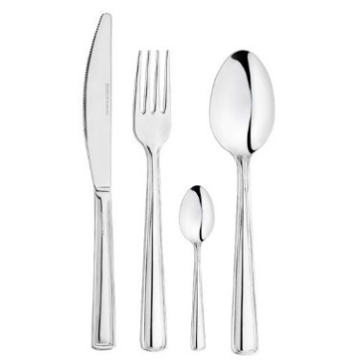**Taħriġ E: X’jisimhom dawn?**

