|  |
| --- |
| **Il-Verb *The Verb ‘to be’*** |

* Fil-Malti għandna xi kliem li għalkemm mhumiex verbi, xorta jintużaw bħala verbi.

*In Maltese we have some words which are used as verbs despite not being verbs themselves.*

* Il-**pronomi personali** jistgħu jintużaw bħala verbi. Dawn huma:

*The* ***personal pronouns*** *can be used as verbs (to be). These are:*

|  |  |  |
| --- | --- | --- |
| **Pronomi Personali** | | |
| **English** | **Maltese** | **example** |
| *I* | Jien / Jiena | Jiena student. ***I am*** *a student.* |
| *You* | Int / Inti | Inti student ***You are*** *a student.* |
| *He* | Hu / Huwa | Huwa student. ***He is*** *a student.* |
| *She* | Hi / Hija | Hija studenta. ***She is*** *a student.* |
| *We* | Aħna | Aħna studenti. ***We are*** *students.* |
| *You* | Intom | Intom studenti. ***You are*** *students.* |
| *They* | Huma | Huma studenti. ***They are*** *students*. |

* *There is no Maltese equivalent for the English neutral pronoun ‘it’.*
* Naraw li fil-Malti il-pronoun personali jservi ta’ pronom u verb fl-istess ħin.

*We see that the Maltese personal pronoun serves as a pronoun and verb at the same time.*

Jiena student = Jiena jien student.

*I am a student.*

**Taħriġ A: Imla l-pronom personali użat bħala verb.**

1. ___________ student tajjeb ħafna.
2. ___________ nersis tajbin.
3. Dak ____________ raġel Malti.
4. Dawk ____________ plejers Ingliżi.
5. Paul ____________ z-ziju tiegħi.
6. Il-qattusa _____________ sewda.

* Il-prepożizzjoni ‘**għand’** tista’ wkoll tintuża bħala verb bis-**suffissi** **pronominali**.

*The preposition ‘****to’***  *can be used as well as a verb (to have) with* ***pronomial suffixes.***

|  |  |  |
| --- | --- | --- |
| **Prepożizzjoni – għand *(to have)*** | | |
| **English** | **Maltese** | **example** |
| *I have* | Jien għand**i** | Jiena għand**i** ktieb. ***I have*** *a book.* |
| *You have* | Int għand**ek** | Int għand**ek** ktieb. ***You have*** *a book.* |
| *He has* | Hu għand**u** | Hu għand**u** ktieb. ***He has*** *a book.* |
| *She has* | Hi għand**ha** | Hi għand**ha** ktieb. ***She has*** *a book.* |
| *We have* | Aħna għand**na** | Aħna għand**na** ktieb. ***We have*** *a book.* |
| *You have* | Intom għand**kom** | Intom għand**kom** ktieb. ***You have*** *a book.* |
| *They have* | Huma għand**hom** | Huma għand**hom** ktieb. ***They have*** ***a*** *book*. |

* Is-suffissi pronominali jintużaw ħafna fil-Malti.

*The pronomial suffixes are heavily used in Maltese.*

**Taħriġ B: Imla l-prepożizzjoni ‘għand’ użata bħala verb.**

1. Aħna _________________ ħafna kotba.
2. Jiena _________________ karozza ġdida.
3. L-għalliem _________________ 60 sena.
4. L-istudenti _________________ test tal-Ingliż.
5. Il-kantant _________________ kitarra tal-elettriku.

**Taħriġ Ċ: Agħżel it-tajba.**

1. Malta (hija / għandu) gżira żgħira.
2. Il-fabbrika (hi / għandha) ħafna ħaddiema.
3. Paul u Chantelle (għandu / għandhom) dar sabiħa.
4. Id-dar (għandha / hija) kbira.
5. Dawk il-vitamini (huma / hija) tajbin.
6. Jien (għandi / għandu) ħafna kotba fil-librerija.
7. Il-librerija (hija / huma) ġdida u sabiħa.

* Il-verb hu kelma li turi stat jew azzjoni.

*The verb is a word that denotes a state or an action.*

Paul huwa wejter. (stat) > *Paul is a waiter.*

Paul jaħdem f’bar. (azzjoni) > *Paul works in a bar.*

* Il-verb jista’ jkun fil-preżent jew fil-passat.

*The verb can be in the present or in the past.*

Paul huwa wejter. (preżent) > *Paul is a waiter.*

Paul kien wejter. (passat) > *Paul was a waiter.*

Paul għandu rota. (preżent) > *Paul has a bicycle.*

Paul kellu rota. (passat) > *Paul had a bicycle.*

* Hawn taħt hawn il-‘pronomi personali’ u ‘għand’ fil-preżent u l-passat.

|  |  |  |  |  |
| --- | --- | --- | --- | --- |
| **Pronomi personali *(to be)*** | | | **Għand *(to have)*** | |
|  | **Preżent** | **Passat** | **Preżent** | **Passat** |
|  | jien | kont | għandi | kelli |
|  | inti | kont | għandek | kellek |
|  | huwa | kien | għandu | kellu |
|  | hija | kienet | għandha | kellha |
|  | aħna | konna | għandna | kellna |
|  | intom | kontu | għandkom | kellkom |
|  | huma | kienu | għandhom | kellhom |

**Taħriġ D: Ikteb fil-passat.**

1. Philip (huwa) _____________ mekkanik tajjeb.
2. Philip (għandu) _____________ garaxx kbir.
3. Dan il-mekkanik (għandu) _______________ ħafna ħaddiema.
4. Il-ħaddiema (għandhom) _______________ paga tajba. *(a good wage)*
5. Jiena (jien) ______________ il-formen fil-garaxx.
6. Philip u jiena (aħna) ______________ studenti l-universita’.
7. Aħna (għandna) ________________ għalliema tajbin. *(good teachers)*

**Taħriġ E: Dawn is-sentenzi qegħdin fl-1el persuna (jien / aħna). Iktibhom fit-3et persuna (huwa / hija / huma).**

***These sentences are in the 1st person (I / we). Rewrite them in the 3rd person (he / she / they).***

1. Jien għandi ħafna ħbieb.

___________________________________________________________________

1. Jien kont ħdejn il-BoV, Marsaskala.

___________________________________________________________________

1. Aħna konna l-iskola ma’ Peter u Charles.

___________________________________________________________________

1. Jiena nħobb il-futbol u l-volibol.

___________________________________________________________________

1. Aħna għandna lezzjoni twila.

___________________________________________________________________ **Taħriġ F: Aqta’ sing taħt it-tajba.**

1. (Dan, Din) il-furketta taqta’ l-ħobż.
2. (Jien, Hu) għandi xogħol tajjeb.
3. (Dak, Dawk) l-ajruplan sejjer l-Ingilterra.
4. Il-pilota (għandu, għandhom) 40 sena.
5. It-teknixins (għandek, għandhom) ħafna esperjenza.
6. Iz-ziju ta’ Peter (huma, huwa) teknixin.
7. Il-kantanti (għandhom, kellu) kanzunetti sbieħ.
8. (Dawk, Dak) il-flixkun hu tal-plastik.
9. (Dak, Din) is-sikkina (hija, huwa) ġdida.

10. Il-karozza qiegħda fil-(kaxxa, garaxx).

11. Il-karozza (kellu, kellha) ftit ħsara.

12. Il-(mekkanik, elektrixin) sewwa l-karozza.

13. L-elektrixin sewwa l-(wajer, kejk) tat-televixin.

**Taħriġ Ġ: Ikteb sentenzi dwar kull stampa. Tista’ tuża l-verbi t’hawn fuq.**

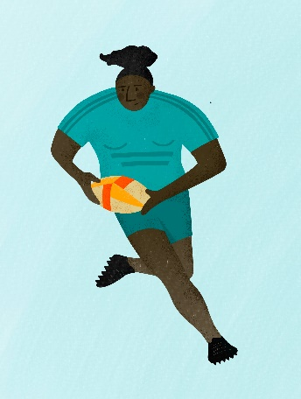

Vic huwa ________________________________________________

Vic _____________________________________________________

_________________________________________________________

_________________________________________________________

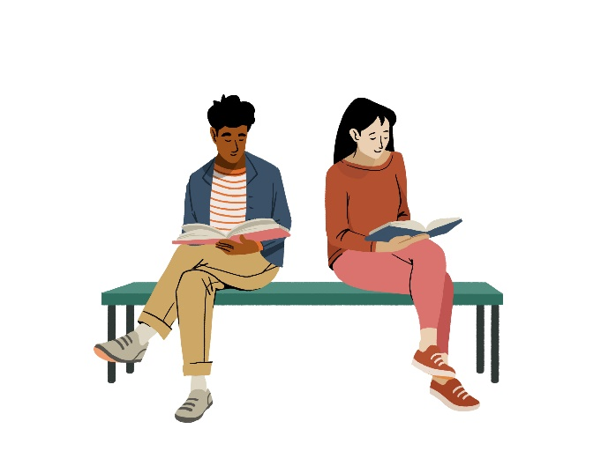

Dawn _______________________________________

____________________________________________

____________________________________________

____________________________________________

____________________________________________

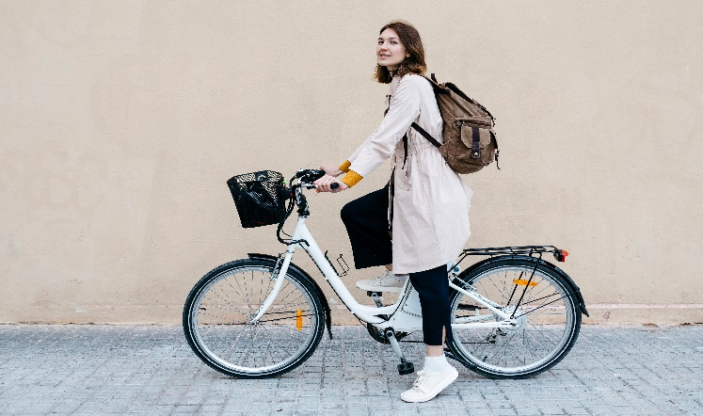

______________________________________

______________________________________

______________________________________

______________________________________

______________________________________

**Taħriġ G: Ikteb xi sentenzi dwarek.**

__________________________________________________________________________________________________________________________________________________________________________________________________________________________________________________________________________________________________________________________________________________________________________________________________________________________________________________________________________________________________________

______________________________________________________________________

**Taħriġ Għ: Ħares lejn l-istampa. Ikteb x’jisimhom l-affarijiet indikati u kompli s-sentenzi.**

***Look at the picture. Label the indicated items and complete the sentences.***

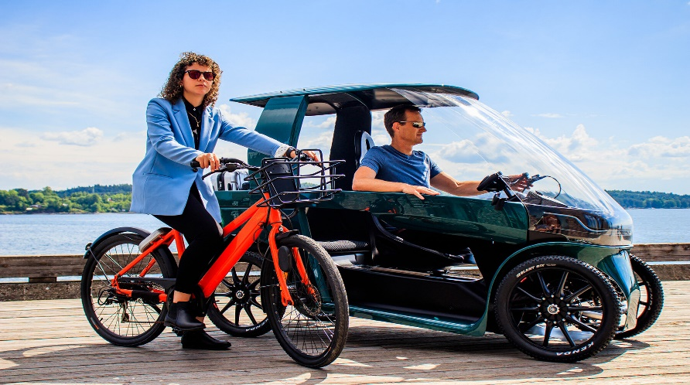

1. Il-mara jisimha ______________________.
2. Ir-raġel jismu ______________________.
3. Il-mara għandha _______________________.
4. _______________________________________.
5. Il-karozza u r-rota _________________________.
6. Dik ir-rota hi ________________________.
7. ____________________________________.
8. Ir-raġel u l-mara qegħdin __________________________.
9. Il-baħar huwa _________________________.
10. Is-sema ___________________________.
11. ________________________________________________________.

**Taħriġ Ħ: Ħares lejn is-sentenzi t’hawn fuq u użahom biex tikteb dwarek.**

***Look at the sentences above and use them to write something about you.***

_____________________________________________________________________________________________________________________________________________________________________________________________________________________________________________________________________________________________________________________________________________________________________________________________________________________