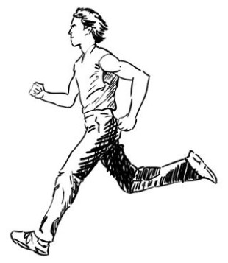**Il-Verb**

Il-Preżent

Meta rridu ngħidu li xi azzjoni nagħmluha kuljum jew

ta’ spiss jew b’mod regolari nużaw il-**Preżent.** Il-Preżent jifforma ruħu biż-żieda ta’**n**, **t,** u **j** quddiem il-Kmand Singular u Plural.

*When we want to describe an action that we do everyday, frequently or on a regular basis we use the Present Tense. The Present Tense is formed by adding* ***n****,* ***t,*** *and* ***j*** *in front of the Imperative verb in Singular and in Plural.*

**Taħriġ A:** Aqra dan il-paragrafu flimkien mal-għalliema u irrepeti l-verbi fil-preżent.

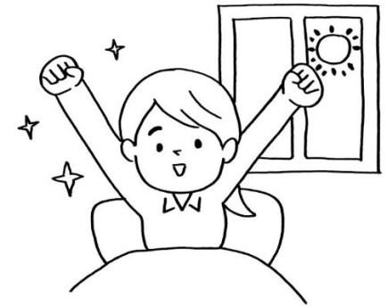*Read the following paragraph together with the teacher and repeat the verbs in the Present Tense.*

X’tagħmel Rita l-infermiera kull filgħodu

qabel titlaq għax-xogħol?

Rita l-infermiera **tqum** fis-sitta u kwart ta’ filgħodu, Hija **toħroġ** mis-sodda,

**tieħu** banju u **taħsel** snienha. Imbagħad **tmur** fil-kċina, **tixrob** tazza te u **tiekol** biċċa ħobż mixwija. Dak il-ħin **taqra** l-gazzetta. Imbagħad **tilbes** u **toħroġ** il-karozza mill-garaxx u **ssuq** għall-isptar.

**Aqra l-verbi li bil-grassett t’hawn fuq u ikteb xi jfissru f’Kolonna B u l-imperattiv f’Kolonna Ċ.**

*Read the verbs in bold and write the meaning in Column B and the verb in Imperative in Column C.*

**Kolonna A**

Verb fil-Preżent (*Verb in the Present Tense)*

tqum

**Kolonna B**

Traduzzjoni (*Translation)*

*to wake up*

**Kolonna Ċ**

L-Imperattiv – Singular/Plural

qum / qumu

toħroġ

tieħu

taħsel

tmur

tixrob

tiekol

taqra

tilbes

toħroġ

ssuq

2

**Taħriġ B**: **Ikkonjuga dawn il-verbi fil-preżent.**

***Conjugate these verbs in the present tense.***

Il-verb mar *(he went).* L-imperattiv *mur / morru.*

1) Jien

2) Inti

3) Huwa 4) Hija 5) Aħna 6) Intom

7) Huma

____________________________________

____________________________________ ____________________________________ ____________________________________ ____________________________________ ____________________________________

____________________________________

Il-verb *ħasel (he washed).* L-imperattiv *aħsel / aħslu.*

1) Jien

2) Inti

3) Huwa 4) Hija 5) Aħna 6) Intom

7) Huma

____________________________________

____________________________________

____________________________________ ____________________________________ ____________________________________ ____________________________________

____________________________________

Il-verb *qam (he woke up).* L-imperattiv *qum / qumu.*

1) Jien 2) Inti

3) Huwa 4) Hija 5) Aħna

6) Intom

7) Huma ____________________________________ ____________________________________ ____________________________________ ____________________________________ ____________________________________

____________________________________

____________________________________

Il-verb *xorob (he drank).* L-imperattiv *ixrob / ixorbu.*

1) Jien 2) Inti

3) Huwa 4) Hija 5) Aħna 6) Intom

7) Huma

____________________________________ ____________________________________ ____________________________________ ____________________________________ ____________________________________ ____________________________________

____________________________________

Il-verb *ġera (he ran).* L-imperattiv *iġri / iġru.*

1) Jien

2) Inti

3) Huwa 4) Hija 5) Aħna 6) Intom

7) Huma

____________________________________

____________________________________ ____________________________________ ____________________________________ ____________________________________ ____________________________________

____________________________________

Il-verb *raqad (he slept).* L-imperattiv *orqod / orqdu.*

1) Jien

2) Inti

3) Huwa 4) Hija 5) Aħna 6) Intom

7) Huma

____________________________________

____________________________________ ____________________________________ ____________________________________ ____________________________________ ____________________________________

____________________________________

4

**Taħriġ Ċ: Irranġa dawn is-sentenzi fl-ordni korretta.**

***Rearrange these sentences in the correct order.***

1) ta’ - fid-disgħa - Toni - filgħaxija - jorqod

________________________________________________________________

2) fil-ħamsa - jqum - Mario - filgħodu - ta’

________________________________________________________________

3) bajda - Romina - jieklu - u - Tanja - kuljum

________________________________________________________________

4) metri - għall-iskola - jiġru - It-tfal - ħames

________________________________________________________________

5) it-tabib - fix-xahar - Toni - darba - għand - jmur ________________________________________________________________

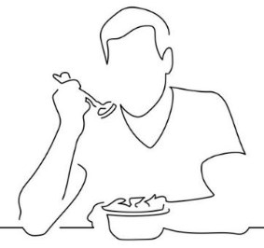

**Taħriġ D: Oħroġ il-preżent tal-verbi li hemm fil-parentesi.**

***Write the present tense of the verbs in the brackets****.*

1) It-tfal jafu ___________________ Malti tajjeb. (iktbu)

2) Ommi ______________________ kmieni. (qum)

3) In-nanna ma tħobbx ________________________ l-ilma. (ixrob)

4) Mario u Wayne ____________________ mixja twila kuljum. (imxu) 5) Maria _________________ il-ġinnastika nhar ta’ Tnejn. (mur)

5