|  |
| --- |
| **L-Għadd tan-Nom  *The Noun - Number*** |

* In-nom jista’ jkun ta’ għadd **singular** jew għadd **plural**. Għadd singular ifisser xi ħaġa waħda; għadd plural ifisser aktar minn ħaġa waħda.

*The noun can be* ***singular*** *or* ***plural*** *in number. Singular number means one; plural number means more than one.*

* Il-**plural** niffurmawh biż-żieda ta’ suffissi mas-singular.

*The* ***plural*** *is formed by adding suffixes to the singular.*

kowt *(coat)* > kowt**ijiet**

aħbar *(news)* > aħbar**ijiet**

baħri *(sailor)* > baħri**n**

barri *(bull)* > barri**n**

student *(student)* > student**i**

turist *(tourist)* > turist**i**

tuffieħa *(apple)* > tuffieħ**a**t

fehma *(opinion)* > fehm**iet**

* Meta kelma tispiċċa b’vokali u s-suffiss li se jiżdied għandu vokali wkoll, l-aħħar ittra tal-kelma taqa’.

*When the word ends with a vowel and the suffix to be attached has a vowel too, the last vowel of the word is dropped.*

bejt**a** *(nest)* > bejt**iet**

siġġ**u** *(chair)* > siġġ**ijiet**

boll**a** *(stamp)* > boll**i**

* Mod ieħor kif isir il-plural hu billi jibdel il-qagħda tal-ittri tas-singular.

*Another way to form a plural is by breaking up the internal structure of the singular form.*

gomma *(rubber)* > gomom

tabib *(doctor)* > tobba

kamra *(room)* > kmamar

**Taħriġ A: Aqleb fil-plural.**

kelma ***(word)*** > _________________ ktieb ***(book)*** > __________________

ħaddiem ***(worker)*** > _________________ karozza ***(car)***  > __________________

klassi *(****class****)* > _________________ artist ***(artist)*** > __________________

* Ħafna drabi kliem tekniku Malti mnissel mill-Ingliż jifforma l-plural biż-żieda ta’ (-s).

*Many times Maltese technical words derived from English form their plural by adding (-s).*

kompjuter > kompjuter**s** swiċċ > swiċi**s**

brejk > brejk**s** lift > lift**s**

**Taħriġ B: Ikteb is-singular jew il-plural u l-kelma bl-Ingliż fejn meħtieġ.**

***Write the singular or plural and the English translation where required..***

|  |  |  |
| --- | --- | --- |
| **Singular** | **Plural** | **English (singulars)** |
| wajer |  |  |
|  | tapiti |  |
|  |  | laptop |
|  |  | mobile phone |
| zija |  |  |
|  |  | helicopter |
| pilota |  |  |
|  | basktijiet |  |
|  |  | television |
| klassi |  |  |
|  |  | spanner |
| fann |  |  |
| arloġġ |  |  |
|  |  | manager |
| lapes |  |  |

**Taħriġ Ċ: X’jisimhom dawn? Żid l-artiklu ma’ kull kelma.**

***What are these called? Add the article to each word.***

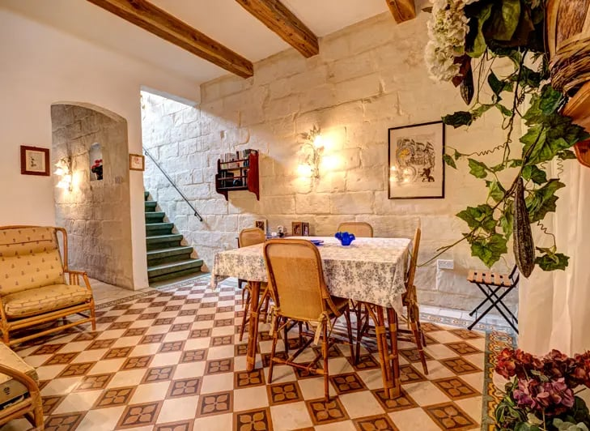

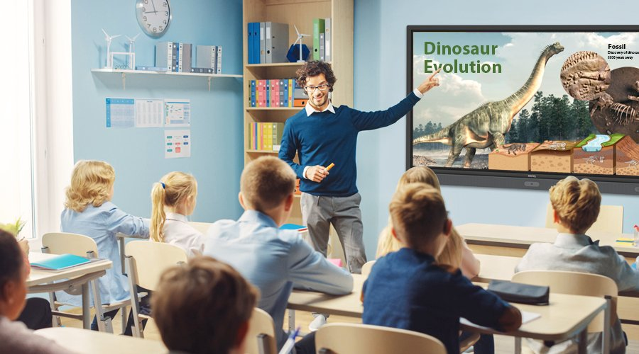

**Taħriġ D:** **Agħmel lista ta’:**

|  |  |  |
| --- | --- | --- |
|  | **Singular** | **Plural** |
| **apparat domestiku** | | |
| https://sp1.yimg.com/ib/th?id=HN.608034680670651729&pid=15.1&P=0 |  |  |
|  |  |
|  |  |
|  |  |
|  |  |
|  |  |
| **affarijiet tal-iskola** | | |
| **Classroom Supplies Poster - Laminated Charts for Homeschool or Preschool  Classroom Decorations | Kindergarten Posters for Classroom Toddler Wall  Decor |( Laminated, 11.7 x 16.5 Inch/29.7 x 42cm ) : Kunal S: Amazon.in:  Books** |  |  |
|  |  |
|  |  |
|  |  |
|  |  |
| **figuri** | | |
| http://www.readtoday.net/en/print-en/shape-4/shape-4-1.gif |  |  |
|  |  |
|  |  |
|  |  |
|  |  |