|  |
| --- |
| **Il-Ġens tan-Nom *The Noun - Gender*** |

* In-nom hu l-isem ta’ xi: **persuna**: raġel – *man*

**annimal**: ħuta – *fish*

**post**: skola – *school*

**ħaġa**: ktieb – *book*

**idea**: gwerra – *war*

*The noun is the name of a: person, animal, place, thing, idea.*

**Taħriġ A: Aqra s-silta u aqta’ sing taħt in-nomi.**

***Read the passage and underline the nouns.***

Fred hu *(is)* mekkanik. Fred joqgħod *(lives at)* Birżebbuġa. Huwa *(he)* jaħdem ġo fabbrika, il-Marsa. Fred iħobb *(likes)* l-isport: il-futbol u t-tenis. Huwa jħobb l-annimali. Għandu *(he has)* kelb u qattus. Il-kelb jismu *(is called)* Rex u l-qattus jismu Yawn.

*List the nouns above in the table below and write whether they are names of persons, animals, places or things. (Use your notes.)*

|  |  |
| --- | --- |
| **Nom** | **persuna, annimal, post, oġġett** |
|  |  |
|  |  |
|  |  |
|  |  |
|  |  |
|  |  |
|  |  |
|  |  |
|  |  |
|  |  |
|  |  |
|  |  |
|  |  |

* In-nom jista’ jkun ta’ ġens **maskil** jew ġens **femminil.**

*The noun can be of a* ***masculine***  *or a* ***feminine*** *gender.*

In-nomi **maskili** huma dawk li jispiċċaw b’konsonanti jew b’vokali (i) jew (u).

***Masculine*** *nouns are those which end in a consonant or a vowel (i) or (u).*

lapes – *pencil* baħar – *sea* desk – *desk* mutur – *motor*

bini  – *building* bidwi – *farmer* bieb – *door*  tabib – *doctor*

kirurgu – *surgeon* waħdu – *al*one teatru – *theatre* ziju – *uncle*

* In-nomi **femminili** huma dawk li ġeneralment jispiċċaw bil-vokali (a).

seringa - *syringe* zija – *aunt*  siġra – *tree*  mejda – *table*

* **Nota**: Hemm xi nomi li ma jimxux ma’ dawn ir-regoli tal-ġens.

***Note****: There are some nouns which do not follow the rules above.*

**Taħriġ B:** **Ikteb maskil jew femminil u l-kelma bl-Ingliż fil-vojt hawn taħt.**

***Write masculine or feminine and the English translation in ths space below.***

|  |  |  |
| --- | --- | --- |
| **Nom** | **Ġens** | **Ingliż** |
| mowbajl |  |  |
| nanna |  |  |
| bank |  |  |
| siġġu |  |  |
| ħobża |  |  |
| omm |  |  |
| siment |  |  |
| eżami |  |  |
| dar |  |  |
| tifla |  |  |
| sport |  |  |
| leptop |  |  |
| skola |  |  |
| uffiċċju |  |  |

**Taħriġ Ċ: Agħti l-maskil jew il-femminil ta’:**

|  |  |  |  |  |
| --- | --- | --- | --- | --- |
| **Maskil** | **Femminil** |  | **Maskil** | **Femminil** |
| xiħ |  |  |  | studenta |
|  | qattusa |  | ziju |  |
|  | tabiba |  |  | għalliema |
| kantant |  |  |  | nanna |
|  | ħaddiema |  | artist |  |
| kelb |  |  |  | mara |
|  | pjanista |  |  | kuġina |

**Taħriġ D: Agħmel lista ta’ nomi bl-Ingliż relatati ma’ post tax-xogħol. Aqlibhom għall-Malti u ikteb humiex maskili jew femminili.**

***Make a list of English nouns related to a place of work. Translate them into Maltese and write whether they are masculine or feminine.***

|  |  |  |
| --- | --- | --- |
| **Noun (English)** | **Noun (Malti)** | **Ġens** |
|  |  |  |
|  |  |  |
|  |  |  |
|  |  |  |
|  |  |  |
|  |  |  |
|  |  |  |
|  |  |  |
|  |  |  |
|  |  |  |
|  |  |  |
|  |  |  |

* Ħafna nies jiġu Malta bħala turisti, biex jaħdmu jew biex jgħixu hawn.

*Many people come to Malta as tourists, to work or to live here.*

* Dawn in-nies jiġu minn pajjiżi differenti.

*These people come from different countries.*

**Taħriġ E: Hawn taħt għandna sett ta’ bnadar. Liema hu l-pajjiż u l-lingwa**

**tiegħu?**

**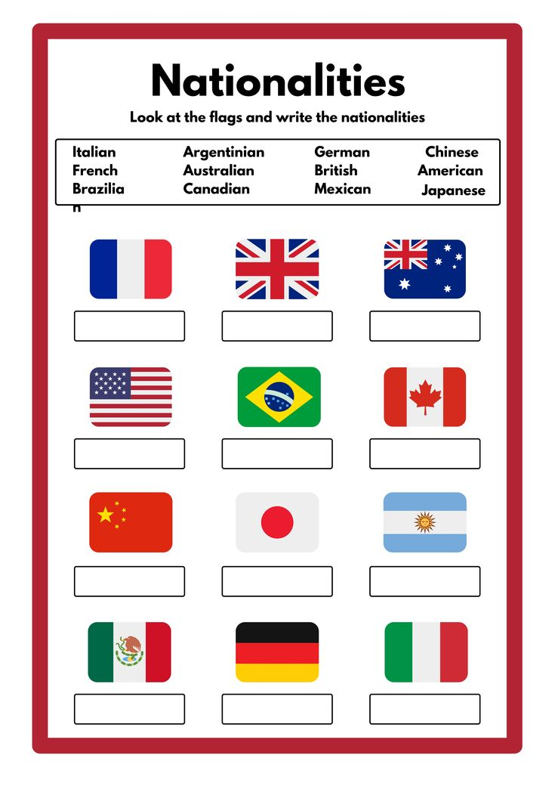 *Here is a set of flags. What is the country and its language represented by each flag?***

*___________________ __________________ _____________________*

 *___________________ __________________ _____________________*

*____________________ ___________________ ______________________*

*____________________ ___________________ ______________________*

*____________________ ___________________ ______________________*

*____________________ ___________________ ______________________*

*___________________ __________________ _____________________*

*___________________ __________________ _____________________*

**Taħriġ F: Kompli ikteb skont l-eżempju.**

***Complete the tasks following the example given.***

Jien Joe.

Jien Awstraljan.

Il-belt kapitali tal-Awstralja hi Kanberra.

Jien __________________.

_______________________________________.

______________________________________________________.

_________________ Pedro.

______________________________________.

______________________________________________________.

_______________________.

_____________________________________.

_____________________________________________________.

*_______________________.*

*_____________________________________.*

*_____________________________________________________.*

______________________.

_____________________________________.

____________________________________________________.

____________________________.

_______________________________________________.

_____________________________________________________.