|  |
| --- |
| **L-Artiklu *The Article*** |

1. L-artiklu fil-Malti hu: [ l- ]. Jintuża qabel nom jew aġġettiv.

*The Maltese article is (l-). It is used before a noun or an adjective.*

l-arloġġ > *the clock* l-għasfur > *the bird*

il-bieb > *the door* il*-*ħaddiem *> the worker*

l-iswed >  *the black* l-abjad > *the white*

kelb > *a dog* għasfur > *a bird*

L-artiklu jintuża biex jiddefinixxi jew jiddetermina nom jew aġġettiv.

*The article is used to define or determine a noun or an adjective.*

1. Meta kelma tibda bl-ittra **m, n, r, s, x** + **konsonanti warajha**, inżidu l-vokali i wara l-artiklu.

*When a word starts with the letter* ***m, n, r, s, x*** *and followed by a* ***consonant****, we add* ***i*** *after the article.*

l-i**mħ**adda l-i**nb**id l-i**sp**aner

1. L-artiklu (l-) jintuża wkoll qabel kliem li jibda bil-vokali **a, e, i, ie, o, u**  u l-konsonanti **għ** u **h.**

*The article (l-) is used as well before words beginning with the vowel* ***a, e, i, ie, o, u***  *and the consonants* ***għ*** *and* ***h.***

l-**a**lbum l-**ie**ħor l-**u**mbrella

l-**għ**asel l-**h**ena

1. L-artiklu ma jiħux il-vokali ­ i meta jiġi wara kelma li tispiċċa bil-vokali.

Morn**a** l-Belt. > *We went to Valletta.*

Niekl**u** l-pizza. > *We eat the pizza.*

5. L-alfabett Malti fih 30 ittra:

A a, B b, Ċ ċ, D d, E e, F f, Ġ ġ, G g,

Għ għ, H h, Ħ ħ, I i, IE ie, J j, K k, L l,

M m, N n, O o, P p, Q q, R r, S s, T t,

U u, V v, W w, X x, Ż ż, Z z.

L-ittri jistgħu jkunu **Vokali**, **Xemxin** jew **Qamrin**.

Il-**vokali** huma: a, e, i, ie, o, u.

Ix-**xemxin** huma: ċ, d, n, r, s, t, x, ż, z. ***Sun*** *consonansts*

Il-**qamrin** huma: b, f, ġ, g, għ, h, ħ, j, k, l, m, p, q, v, w. ***Moon*** *consonants*

Quddiem kliem li jibda b’konsonanti **xemxija** l-artiklu jsir bħalha.

*If a word starts with a sun consonant, the article changes to match with the first consonant of the word.*

i**r**-**r**aġel i**x**-**x**aft i**ż**-**ż**ejt i**n**-**n**aħal

**NOTA:**

Il-vokali  **i** tal-artiklu jgħidulha vokali tal-leħen. Din tintuża jekk qabel u wara l-artiklu jkun hemm konsonanti.

*The vowel*  ***i***  *of*  ***il-*** *is called the euphonic vowel. This is used if before and after the article there is a consonant.*

Da**n** il-**k**tieb sabiħ. > *This is a nice book.*

Da**n** il-**k**ompjuter tajjeb. > *This is a good computer.*

6. Ma niktbux l-artiklu quddiem:

*We don’t use the article before:*

Ismijiet ta’ nies *Rajt lil Toni.*

*Names of people I saw Tony.*

Ismijiet ta’ bliet u gżejjer żgħar *Mort Ruma u Ċipru.*

*Names of cities and small islands I went to Rome and Cyprus.*

Xi ismijiet ta’ pajjiżi jew irħula Maltin. *Ġejt minn Bormla.*

*Some names of Maltese places or towns. I’ve come from Bormla.*

**Taħriġ A: Poġġi l-artiklu fejn meħtieġ.**

***Fill in the article where needed.***

______ mejda _____ fjus ______ vjolin _____ kitla

______ spalla _____ omm ______ stat _____ Kroazja

______ Franza _____ eżami ______ mħabba _____ Italja

______ spagetti _____ Philip ______ għalliem ____ ħabib

______ arloġġ _____ element ______ ilma _____ saqqu

______ spaner _____ stilla ______ statwa _____ sport

______ mużika _____ ħġieġ ______ friġġ _____ drama

______ ċirasa _____ dar ______ nar _____ sena

______ vitamini _____ umbrella ______ riżultati _____ Spanja

______ teatru _____ Żejtun ______ student _____ lift

**Taħriġ B: Imla l-artiklu fejn meħtieġ.**

1. Dan ____ siġġu tajjeb. *This is a good chair.*
2. Għandi ____ ktieb ta’ _____ Peter. *I have Peter’s book.*
3. ____ Italja hi kbira imma ____ Malta żgħira.

*Italy is large but Malta is small.*

1. ____ raġel u ____ mara marru ____ Spanja.

*The man and the woman went to Spain.*

1. Dan ____ siġġu miksur. *This chair is broken*.
2. Għandha ____ basket fejn ____ desk. *She has her bag near the desk.*
3. ____ teknixin sewwa ____ televixin u ___ kompjuter.

*The technician mended the television and the computer.*

1. Aqra ____ ktieb u ____ gazzetta. *Read the book and the newspaper.*

**Taħriġ Ċ: Isma’ l-għalliem u ttikkja t-tajba.**

***Listen to your teacher and tick the correct word.***

|  |
| --- |
|  |

kaxxa ___ il-kaxxa ___ omm ____ l-omm ___

nannu ___ in-nannu ___ flixkun ____ il-flixkun ___

televixin ___ it-televixin ___ bieb ____ il-bieb ___

għasel ___ l-għasel ___ arloġġ ____ l-arloġġ ___

spaner ___ l-ispaner ___ mejda ____ il-mejda ___

**Taħriġ D: Sewwi fejn meħtieġ.**

1. Il-tifel mar il-dar. *The boy went home.*

*_____________________________________*

1. Dora għandha il-basket fuq l-mejda. *Dora has the bag on the table.*

_____________________________________

1. Il-elektrixin sewwa il-swiċċ. *The electrixin fixed the switch.*

_____________________________________

1. Iż-ziju mar iz-Żejtun. *My uncle went to Żejtun.*

­­­­­­­­­­­­­­­­­­­­­­­­­­­______________________________________

1. Il-nannu għandu il-album tal-familja. *My grandpa has the family album*.

*­*______________________________________

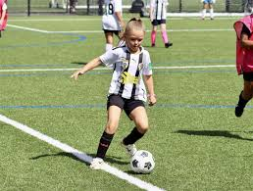**Taħriġ E: Aqra.**

Marija u Pedro huma studenti żgħar.

Marija u Pedro huma studenti tal-Primarja.

Marija għandha għaxar snin.

Pedro għandu disa’ snin.

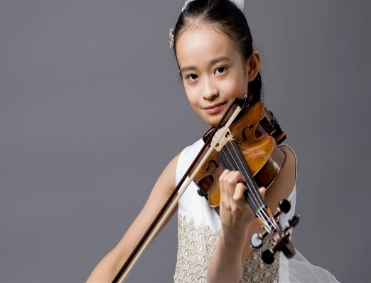Pedro jħobb l-isport. Huwa jilgħab il-futbol kuljum.

Marija tħobb il-mużika. Hija ddoqq il-vjolin u l-pjanu.

Pedro u Marija jistudjaw ħafna.

Pedro irid isir tabib u Marija trid issir vjolinista.

Pedro u Marija huma studenti tajbin ħafna.

**Taħriġ F: Żid kelma wara l-artiklu.**

il- _____________________ iz- ____________________

l- _____________________ ir- ____________________

it- _____________________ id- ____________________

in- _____________________ iċ- ____________________