|  |
| --- |
| **Il-Ħwejjeġ u l-Kuluri *Clothing and Colours*** |

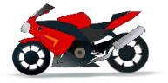

**Il-kuluri bil-Malti**

*The colours in Maltese*

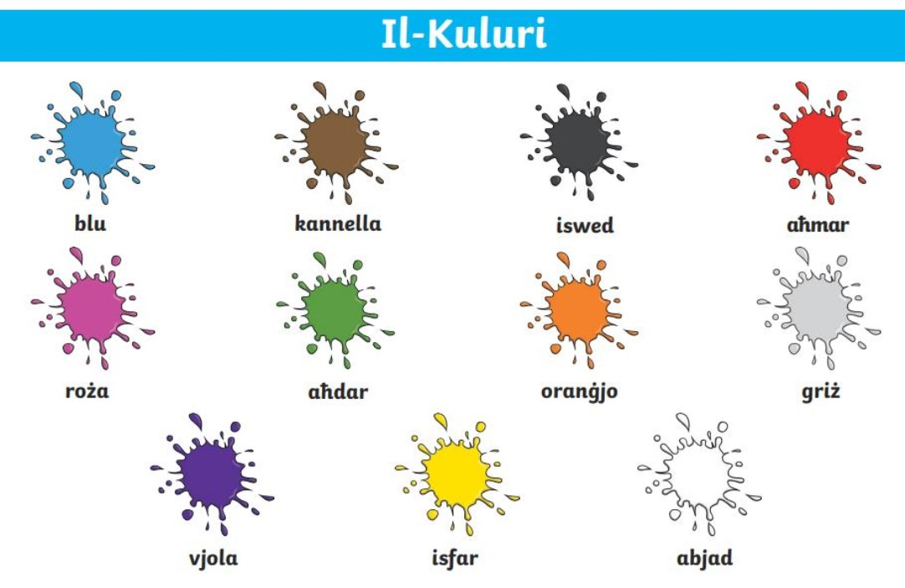

➢ Bil-Malti ċerti kuluri jingħadu differenti skont il-ġens u l-għadd tan-nom.

*In Maltese some of the colours in gender and number of the noun.*

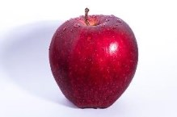

aħmar (m)

______________ aħmar

ħamra (f)

________________ ħamra

ħomor (pl.)

________________

ħomor

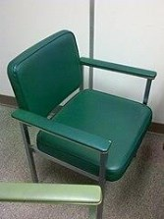

aħdar (m)

_________ aħdar

isfar (m)

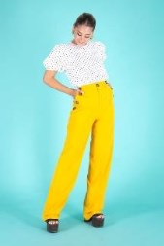

_________ isfar

abjad (m)

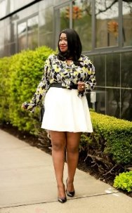

_______[_ abja](https://creativecommons.org/licenses/by-nc-nd/3.0/)d

ħadra (f)



___________ħadra

safra (f)

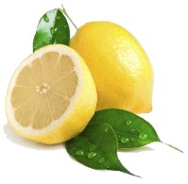

_____________ safra

bajda (f)

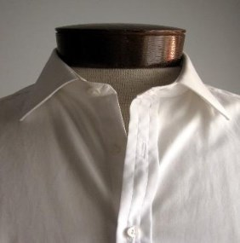

______________[_ bajd](https://creativecommons.org/licenses/by/3.0/)a

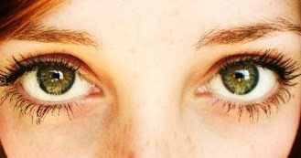ħodor (pl.)

________________ ħodor

sofor (pl.)

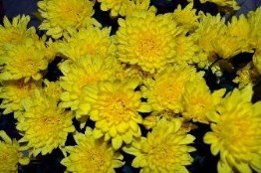

______________ sofor

bojod (pl.)

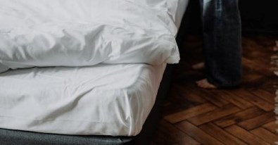

________________ bojod

iswed (m)

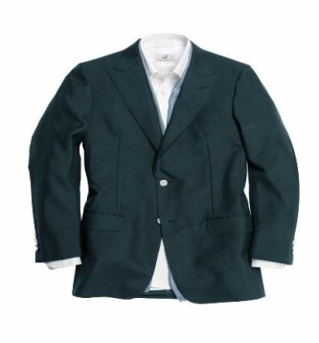

_____________ iswed

griż (m)

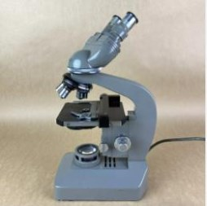

_______________griż

sewda (f)

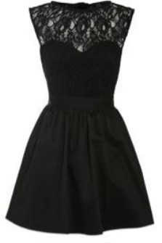

______________sewda

griża (f)

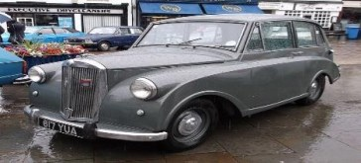

________________ griża

suwed (pl.)

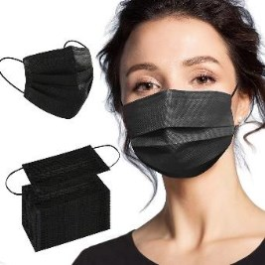

________________ suwed

griżi (pl.)

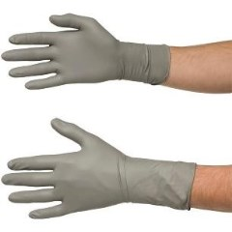

________________ griżi

**FTAKAR:** Il-bqija tal-kuluri jibqgħu l-istess, ikun xi jkun in-nom li jkun hemm qabilhom.

***REMEMBER***: *The rest of the colours remain the same, irrelevant of the type of the noun*

*that comes before them.*

**Taħriġ A: Agħżel il-kulur li jaqbel man-nom.**

1. sufan *a sofa* (iswed, suwed, sewda)

2. bieb *a door* (abjad, bajda, bojod)

3. platti *plates* (abjad, bojod, bajda)

4. lumija *a lemon* (ħamra, safra, griża)

5. tajers *tyres* (ħodor, suwed, sofor)

6. demm *blood* (ħomor, aħmar, griż)

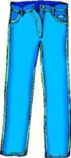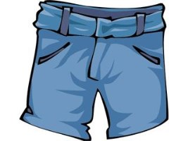**Il-Ħwejjeġ**

***Clothes***

➢ **Aqra l-kelma bil-Malti u ikteb il-verżjoni bl-Ingliż.**

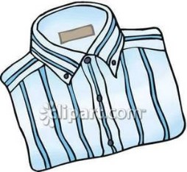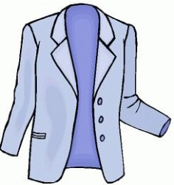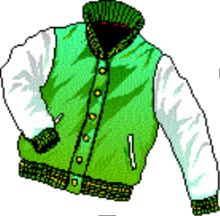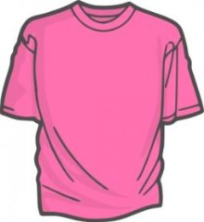*Read the Maltese version and write the English version.*

Qmis = ġlekk =

flokk tal-komma ġins

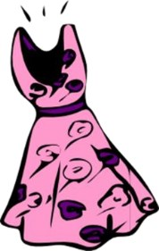



piġama = libsa =

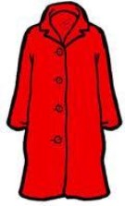

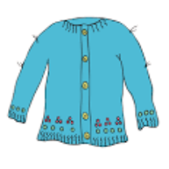

ġerżi = kowt =

ġakketta =

xorz =

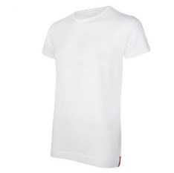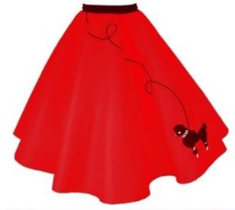

dublett =

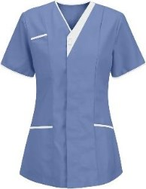

blaws =

flokk tal-komma

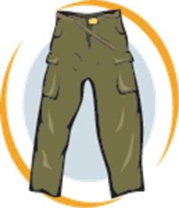qasira =

qalziet =

flokk =

ħwejjeġ ta’ taħt=

**L-Aċċessorji**

***The Accessories***

➢ **Aqra l-kelma bil-Malti u ikteb il-verżjoni bl-Ingliż.**

*Read the Maltese version and write the English version.*



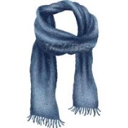

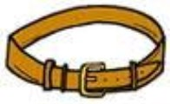

kappell = xalla = ċintorin = beritta = ingravata =

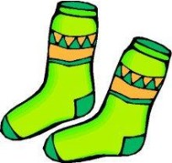

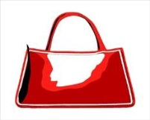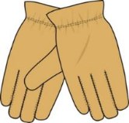

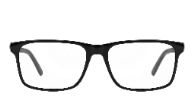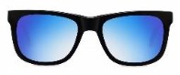

ingwanti = basket = kalzetti = nuċċali tal-vista =

nuċċali tax-xemx =

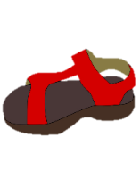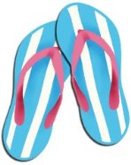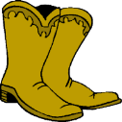

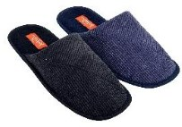

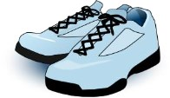

buz = papoċċ = karkur = sandli = papoċċ tas-

sodda =

**Taħriġ A**: **Qabbel il-kelma mal-istampa.**

***Match the word with the picture.***

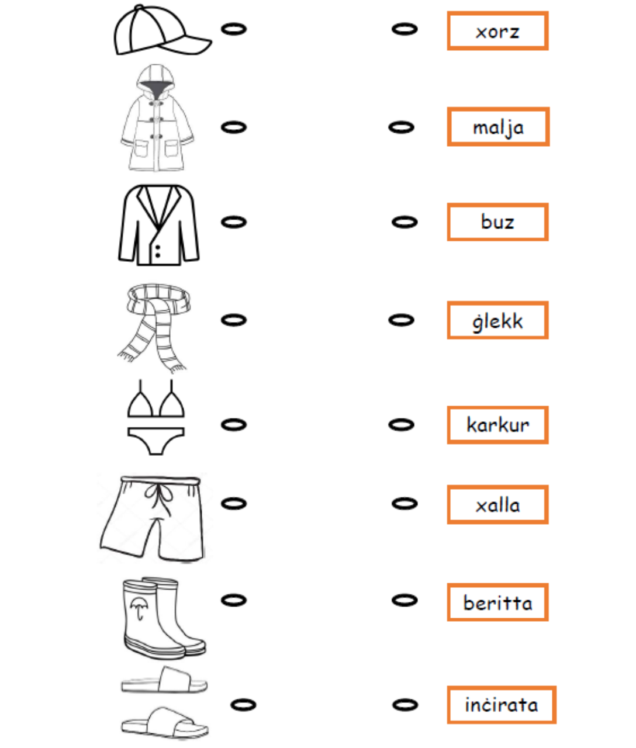

**Taħriġ B: Immarka l-kliem li jaqblu mal-istampa b’√.**

***Mark the words corresponding to the pictures shown****.*

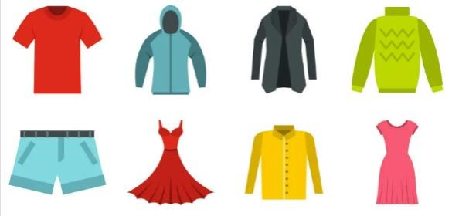

□ qalziet

□ libsa

□ dublett

□ flokk tal-komma qasira

□ ġerżi

□ ġakketta

□ inċirata

□ qmis

□ ċintorin

□ kowt

□ xorz

**Taħriġ Ċ: Ikteb sew il-kelmiet.**

***Write the words correctly.***

|  |  |  |  |  |  |
| --- | --- | --- | --- | --- | --- |
| 1 | smiq |  | 2 | bunażar |  |
| 3 | ċapoċp |  | 4 | nadlis |  |
| 5 | ztielaq |  | 6 | notniċir |  |
| 7 | wsalb |  | 8 | tiztekal |  |
| 9 | ganitwin |  | 10 | ċulnċai |  |

**Taħriġ D: X’inhuma dawn bil-Malti?.**

***What are these in Maltese?.***

|  |  |  |
| --- | --- | --- |
| 1 | worn on the head |  |
| 2 | you put things in it when you go out |  |
| 3 | footwear to protect you from rain |  |
| 4 | worn in bed |  |
| 5 | worn around the neck when very cold |  |

**Taħriġ E: X’inhuma libsin? Agħti lista tal-ħwejjeġ li jidhru fl-istampa. Żid ukoll il-kulur!**

***What are they wearing? Make a list of clothes you see in the picture. Add the colour as well!***

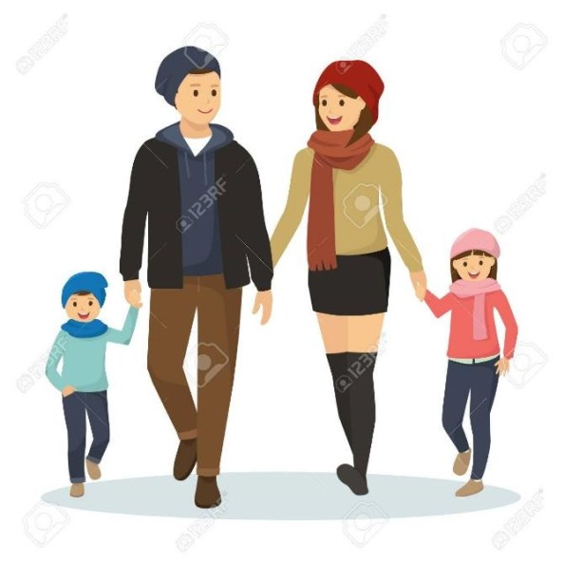

|  |  |  |
| --- | --- | --- |
| 1 | flokk tal-komma twila | roża |
| 2 |  |  |
| 3 |  |  |
| 4 |  |  |
| 5 |  |  |
| 6 |  |  |
| 7 |  |  |
| 8 |  |  |

*10*

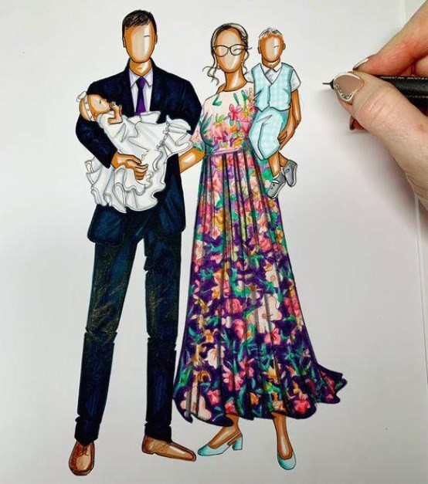

|  |  |  |
| --- | --- | --- |
| 1 | ingravata | sewda |
| 2 |  |  |
| 3 |  |  |
| 4 |  |  |
| 5 |  |  |
| 6 |  |  |
| 7 |  |  |
| 8 |  |  |

**Taħriġ F: Aqra dan id-djalogu u ipprattikah f’pari.**

***Read the following dialogue and practise it in pairs.***

**Djalogu 1: Bejn Maria u Rita.**

Maria: Bonġu Rita.

Rita: Bonġu Maria. Kif inti?

Maria: Tajba grazzi. U int?

Rita: Mhux ħażin grazzi. **X’ser tilbes** illejla għall-festin?

Maria: Ilejla **se nilbes** libsa roża u sandli iswed. U inti?

Rita: Jien kont se nilbes flokk isfar u qalziet blu.

Maria: Tajjeb ħafna. Narak.

Rita: Narak.

**Issa immaġina li għandek festin. Bejn tnejn iktbu djalogu.**

***Imagine you have a party. Write a dialogue in pairs.***

_____________________________________________________________________________________________________________________________________________________________________________________________________________________________________________________________________________________________________________________________________________________________________________________________________________________________________________________________________________________________________________________________________________________________________________________________________________________________________________