|  |
| --- |
| **L-Aġġettiv *The Adjective*** |

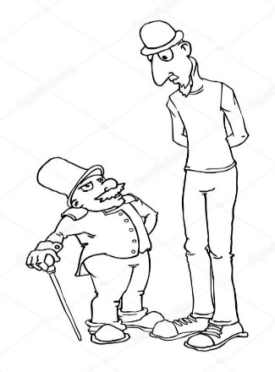

* X’inhu aġġettiv?

*What is an adjective?*

L-aġġettiv huwa kelma li tiddeskrivi.

*An adjective is a word that describes.*

eżempju: sabiħ ikrah twil qasir oħxon irqiq

*nice ugly tall short fat slim*

* Ġeneralment, fil-Malti, l-aġġettiv insibuh wara n-nom.

*Generally, in Maltese, the adjective is used after the noun.*

eżempju: tifel **qasir** mara **twila** raġel **dħuli**

a **short** boy *a* ***tall*** *lady a* ***friendly*** *man*

* Fil-Malti, l-aġġettiv irid jaqbel man-nom:

*In Maltese, the adjective has to agree with the noun:*

* jekk in-nom huwa fis-**singular**, l-aġġettiv irid ikun fis-**singular**:

*if the noun is* ***singular****, the adjective is* ***singular***

student **bravu** *an* ***intelligent*** *student*

* jekk in-nom huwa **femminil**, l-aġġettiv irid ikun **femminil**

*if the noun is* ***femminil****, the adjective is* ***femminil***

studenta **brava** *an* ***intelligent*** *student*

* jekk in-nom huwa fil-**plural**, l-aġġettiv irid ikun fil-**plural**

*if the noun is* ***plural****, the adjective is* ***plural***

studetni **bravi** ***intelligent*** *students*

* B’mod ġenerali, inbiddlu l-aġġettiv minn maskil għal femminil billi nżidu **-a** wara l-aġġettiv.

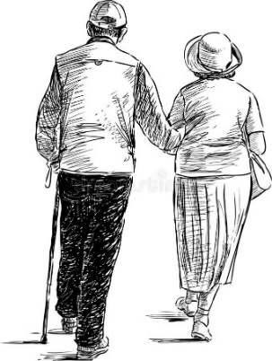*Generally, we change a masculine adjective to a feminine adjective by adding* ***-a***  *to the adjective.*

eżempju: xiħ – xiħ**a** *old*

kbir – kbir**a** *big*

twil – twil**a** *tall*

* Il-kuluri huma wkoll aġġettivi.

*Colours are also adjectives.*

eżempju: mutur iswed qalziet blu żarbun kannella

*black motorcycle blue trousers brown shoes*

**Taħriġ A:** Aqra l-aġġettivi t’hawn isfel u fit-tieni kolonna ikteb it-**traduzzjoni** tagħhom bl-Ingliż, imbagħad qassamhom f’**maskil, femminil u plural.**

*Read the adjectives below, write the* ***translation*** *in the second column, then tick whether they are* ***masculine, feminine or plural.***

|  |  |  |  |  |
| --- | --- | --- | --- | --- |
| **L-aġġettiv** | **traduzzjoni bl-Ingliż** | **maskil** | **femminil** | **plural** |
| twila | tall |  | *√* |  |
| isfar |  |  |  |  |
| tajjeb |  |  |  |  |
| kburi |  |  |  |  |
| żgħar |  |  |  |  |
| tajba |  |  |  |  |
| safra |  |  |  |  |
| żgħir |  |  |  |  |
| twal |  |  |  |  |
| kburija |  |  |  |  |
| sofor |  |  |  |  |
| kburin |  |  |  |  |
| tajbin |  |  |  |  |
| żgħira |  |  |  |  |
| twil |  |  |  |  |

**Taħriġ B:** Qabbel in-nomi f’kolonna A mal-aġġettivi fl-kolonna B.

*Match the nouns in column A with the adjectives in column B.*

**A B**

* qattus □ □ suwed
* qattusa □ □ sewda
* qtates □ □ iswed
* mutur □ □ ħomor
* karozza □ □ ħamra
* vetturi □ □ aħmar

__________________________________________________

* kelb □ □ kbar
* kelba □ □ kbir
* klieb □ □ kbira

_________________________________________________

* dar □ □ interessanti
* appartament □ □ kbira
* vilel □ □ żgħir
* sodda □ □ bravi
* storja □ □ komda
* studenti □ □ sbieħ

__________________________________________________

* sufan □ □ komdu
* mejda □ □ bojod
* karti □ □ twila

__________________________________________________

* qalziet □ □ sofor
* lapsijiet □ □ safra
* purtiera □ □ isfar

**Taħriġ Ċ:** Aqra dawn is-sentenzi u aqta’ linja taħt l-aġġettivi.

 *Read the following sentences and underline the adjectives.*

1. Oħti għandha xagħarha twil u kannella.
2. Ħija mar jixtri ġelat tajjeb.
3. L-isptar rajt tifel oħxon u twil liebes gakketta blu.
4. L-ambulanza kienet ġdida u kbira.
5. L-uniformi kienet ħadra u nadifa.

**Taħriġ D:** Aqra dan il-paragrafu u aqta’ linja taħt l-aġġettivi.

*Read the following paragraph and underline the adjectives.*

L-istudenta jisimha Katrina. Għandha għajnejha kannella u xagħarha iswed. Katrina hija qasira u rqiqa. Hija studenta organizzata ħafna. Katrina tħobb ix-xjenza. Tħobb taqra dwar il-bijoloġija. La tikber tixtieq issir tabiba.

Katrina hija tifla tajba għax hija ġeneruża u tħobb tieħu ħsieb lil kulħadd. Hija studenta edukata u intelliġenti.