|  |
| --- |
| **Id-Dar *The House*** |

* Id-dar Maltija hija magħmula mill-ġebel jew brikks.

*Maltese houses made of stone or concrete bricks.*

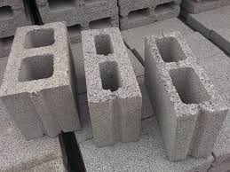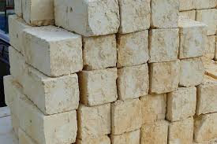

**ġebla tal-franka brikks**

***stone bricks***

* Din hija faccata ta’ dar tipikament Maltija. Semmi il-partijiet.

*This is a typical Maltese house facade. Label it.*

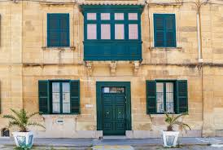

* Dar ġeneralment ikollha:

*A house usually has:*

* kamra tas-sodda *bedroom*
* kamra tas-salott *sitting room*
* kamra tal-kċina *kitchen*
* kamra tal-banju *bathroom*
* garaxx *garage*
* bejt *roof*
* Ħares lejn l-istampa ta’ **kamra tas-sodda** u semmi l-oġġetti murija.

*Look at the picture of a* ***bedroom*** *below and label it.*

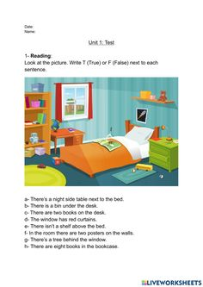

* **Wieġeb dawn il-mistoqsijiet dwar il-kamra tas-sodda.**

***Answer these questions related to the bedroom.***

1. X’hemm fuq it-tapiti? ______________________________________________

*What is there on the carpets?*

1. X’hemm fil-librerija? _______________________________________________
2. X’hemm fuq il-librerija? ____________________________________________
3. X’hemm fuq l-ixkaffa? _____________________________________________
4. Fejn hu d-desk? __________________________________________________

*Where is the desk?*

* **Semmi l-affarijiet billi tikteb l-ittra li taqbel.**

***Label the pictures by writing the corresponding letter.***

**id-dar il-kamra tal-banju**

a. bieb b. tieqa ċ. siġra a. sink b. mera ċ. banju

d. ċumnija e. bejt f. taraġ d. xugaman e. tapit f. tojlit

**il-kamra tal-kċina il-kamra tas-salott**

a. friġġ b. tapit ċ. forn a. inkwadru b. tapit ċ. sufan

d. armarju e. xkupa f. pala d. purtieri e. junit f. pjanta

ġ. arloġġ g. mejda għ. siġġu ġ. tieqa g. lampa għ. art

* **Daħħal prepożizzjoni li turi ‘fejn’.**

***Use a preposition of place****.*

1. Is-sufan qiegħed ___________ it-tapit.
2. L-inkwadru qiegħed __________ ħajt.
3. Il-lampa qiegħda ___________ is-sufan.
4. Il-pjanta qiegħda ___________ is-sufan.
5. It-tapit qiegħed ____________ is-sufan.

* Ħares lejn l-istampa. Ikteb sentenzi dwarha bħat-taħriġ ta’ qabel. Uża dawn il-kelmiet: tapit, mera, junit, kowt.

***Look at the picture below. Write sentences about it like the ones in the exercise above. Use these words: carpet, mirror, unit, coat.***

**____________________________________________________________________________________**

**____________________________________________________________________________________**

**____________________________________________________________________________________**

**____________________________________________________________________________________**

**____________________________________________________________________________________**

* **Aqra din is-silta u aqta’ sing taħt il-kliem dwar id-dar.**

***Read this passage and underline the words related to the house.***

Jiena Ravi. Jien għandi dar sabiħa ħafna.

Id-dar għandha bieb ta’ barra kannella u tliet twieqi. Ħdejn id-dar hemm siġra kbira. Jien nipparkja l-karozza fil-garaxx.

Id-dar fiha kċina, kamra tal-ikel, żewġ kmamar tas-sodda u kamra tal-banju u kamra tas-salott.

Fil-kamra tal-kċina hemm mejda kbira u sitt siġġijiet. Fil-kamra tas-salott hemm sufan blu u komdu.

Fil-kamra tas-sodda tiegħi għandi sodda komda u komodina, mejda u siġġu u librerija bil-kotba.

_ _ _ _ _