|  |
| --- |
| **Ikel u Xorb *Food and Drink*** |

Hawn taħt hawn sett stampi ta’ ikel u xorb. X’inhuma bil-Malti?

*Here is a set of food and drink pictures. What are they called in Maltese?*

__________________ _________________

_________________ _________________

__________________ ________________________

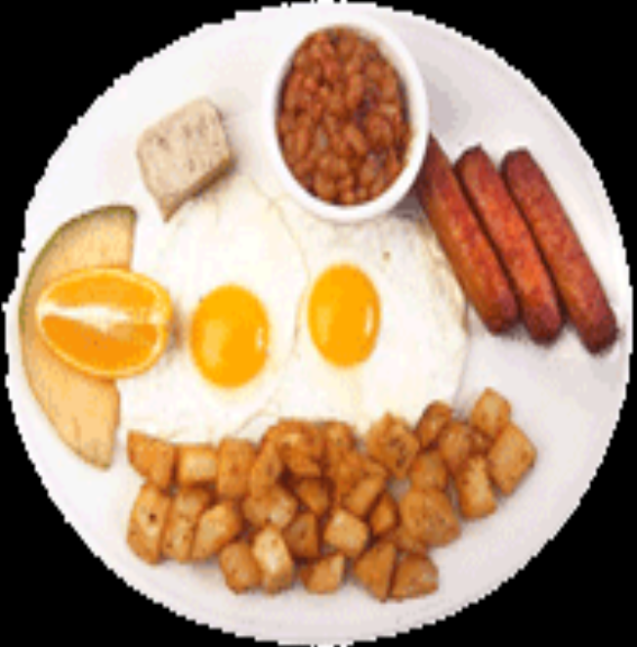

__________________ __________________

__________________ _________________

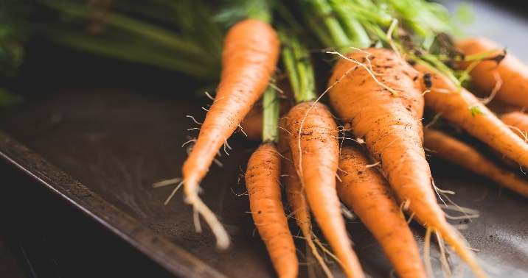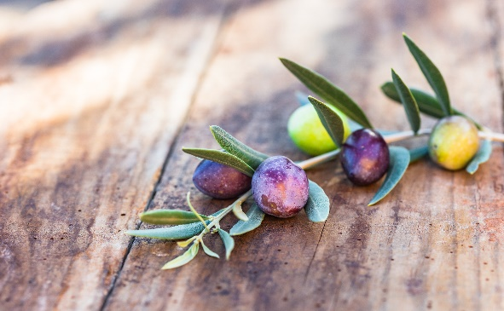

_______________________________ ______________________________

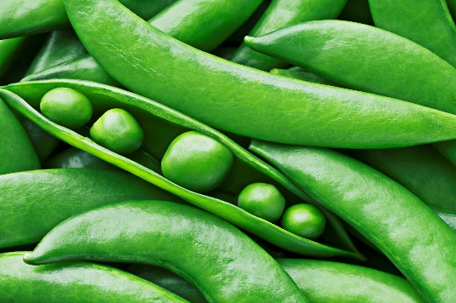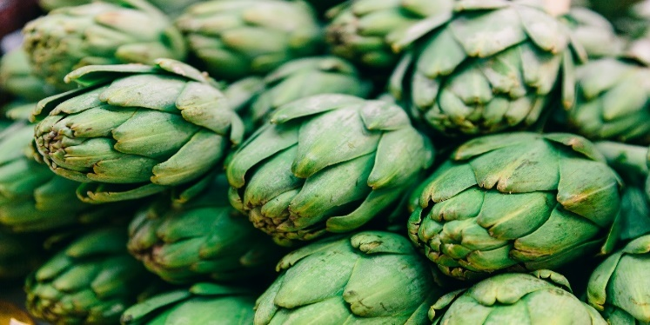

_______________________________ _______________________________

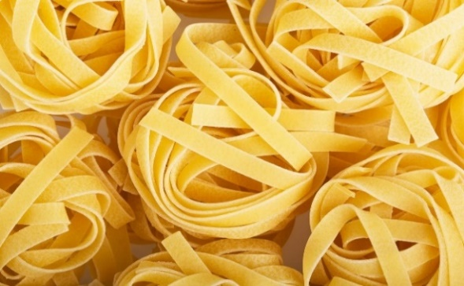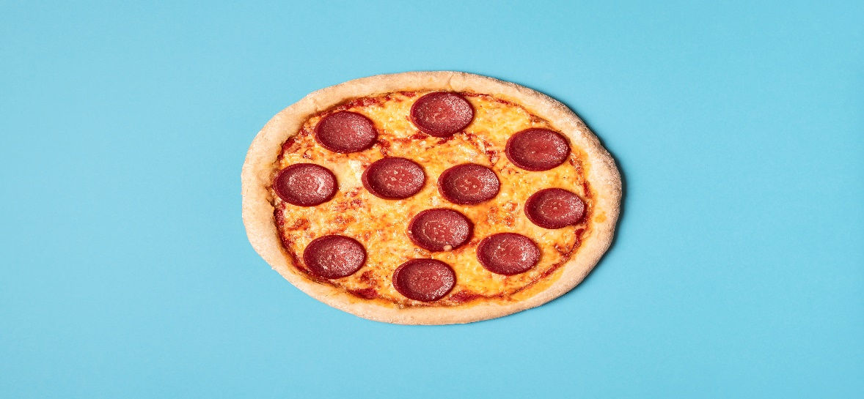

_________________________________ _____________________________

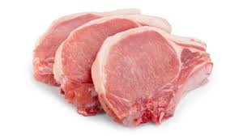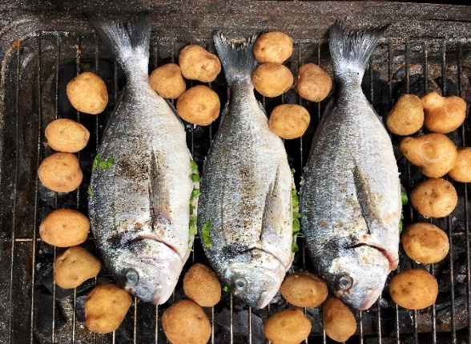

_________________________________ _____________________________

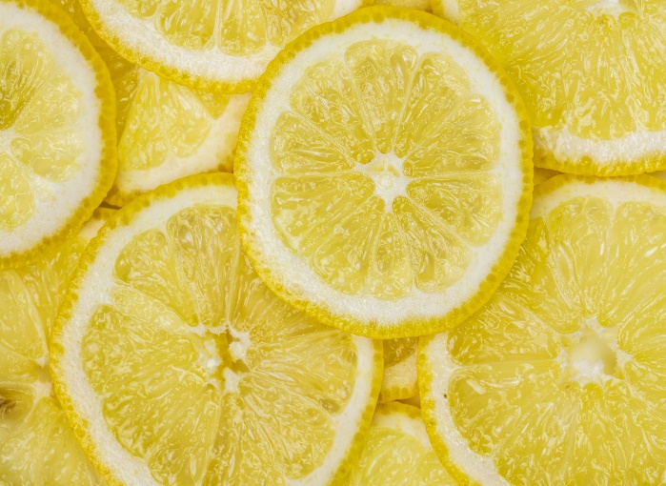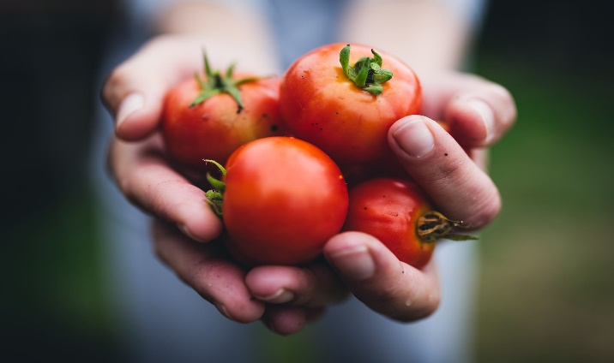

________________________________ _____________________________

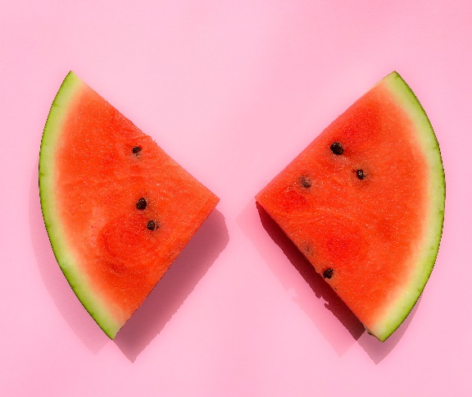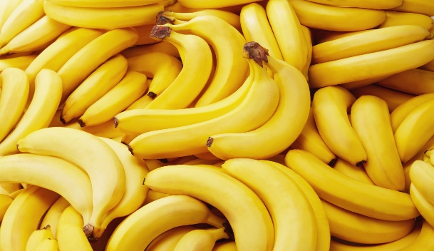

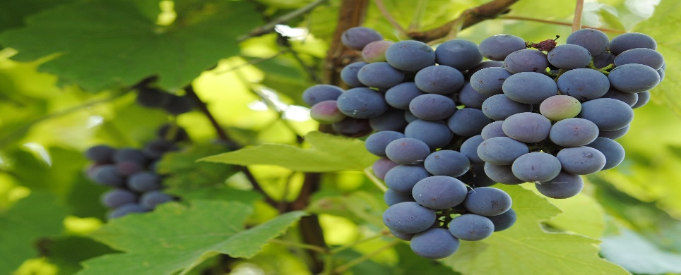__________________________________ _____________________________

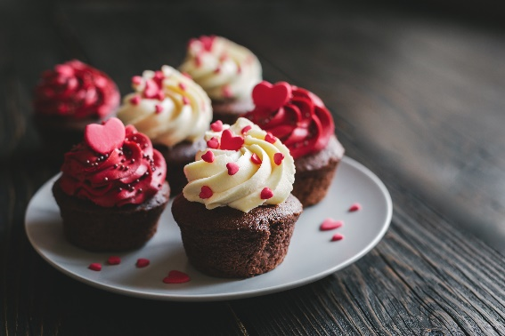

__________________________________ _____________________________

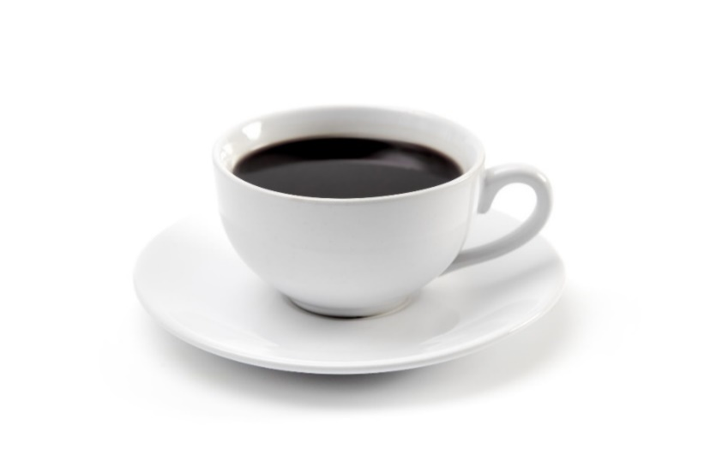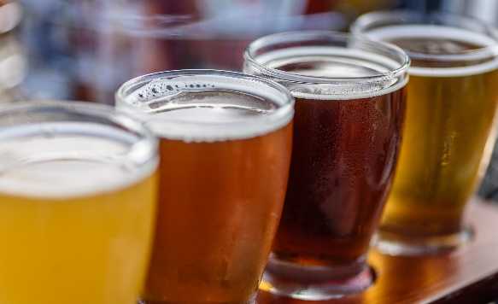

___________________________________ _____________________________

* Ikteb in-numru tal-istampa u fit-tabella isfel daħħal in-numru u l-isem tal-

istampa.

2

1

|  |  |  |
| --- | --- | --- |
| 1. te | 1. waffles |  |
|  |  |  |
|  |  |  |
|  |  |  |
|  |  |  |
|  |  |  |
|  |  |  |
|  |  |  |
|  |  |  |
|  |  |  |

**Dieta tajba**

***A healthy diet***

prodotti tal-ħalib

Laħam, ħut u alternattivi

Ikel li fih ix-xaħam u z-zokkor

ħobż, ċereali u patata

frott u ħaxix

1. Kemm hemm gruppi ta’ ikel li jagħmlu dieta tajba? ____________________­­­____

*How many groups of food make up a heathy diet?*

1. Agħmel ċirku madwar il-grupp ta’ ikel li għandek tiekol l-inqas.

*Encircle the chart to mark the group of foods you should eat least.*

1. F’liema grupp huwa l-meraq tal-laring? __________________________________

*In which group of foods is fresh orange juice?*

1. Liema għandek tiekol iktar, laħam jew ħaxix? ______________________________

*Which should you eat more of, meat or vegetables?*

* Ikkonjuga dawn il-verbi fil-preżent.

*Conjugate these verbs in the present tense.*

|  |  |  |  |
| --- | --- | --- | --- |
| **xorob** | | **kiel** | |
|  | |  | |
| Jien |  | Jien |  |
| Inti |  | Inti |  |
| Huwa |  | Huwa |  |
| Hija |  | Hija |  |
| Aħna |  | Aħna |  |
| Intom |  | Intom |  |
| Huma |  | Huma |  |

* Imla il-preżent tal-verb (xorob / kiel) u l-isem tal-oġġett fl-istampa.

*Fill in the correct present tense form (of ‘xorob’ / ‘kiel’) and the name of the object in the picture.*

1. 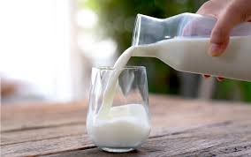Jiena __________________ ħafna 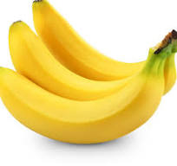 ___________________.
2. Il-pazjenta __________________ il- _____________________

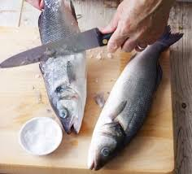

1. Intom tħobbu __________________ ________ frisk kuljum.

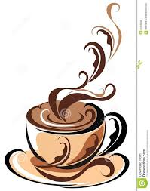

1. Wara l-ikel __________________ u __________________ pasta.

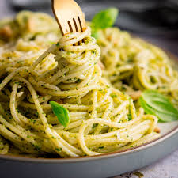

1. Il-Taljani jħobbu _________________ l- ____________________

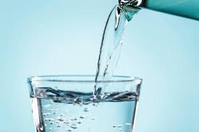

u l-Maltin jħobbu _________________ l- ______________

* Aqra u ikteb jekk kull sentenza hix **vera** jew **falza**

*Read and decide whether each sentence is* ***true*** *or* ***false*.**

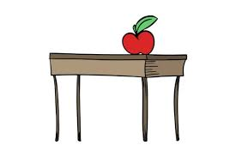

1. It-tuffieħa qiegħda fuq il-mejda. ___________

1. Il-mejda għandha tliet saqajn. ___________

1. Taħt il-mejda hemm qattus. ___________

1. Fuq il-mejda hemm pizza u tuffieħa. ___________

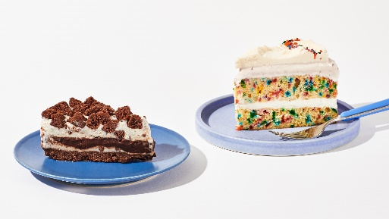

1. Fil-platti hemm kejk u pizza. ___________
2. Il-kejkijiet huma tajbin. ___________

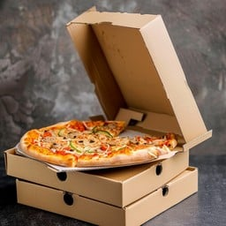

1. Il-kaxxa ta’ fuq fiha pizza. ___________

1. Fil-kaxex hemm tliet pizez. ____________
2. Jiena nixrob il-pizza. ____________

1. 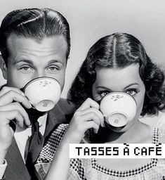 Il-missier qiegħed jixrob l-ilma. ___________

1. It-tifla qiegħda tixrob il-kafè. ___________
2. Il-missier u t-tifla jħobbu jieklu il-kafè.

__________

1. It-tifla għandha libsa sewda. __________

* L-għalliem se jaqra żewġ kelmiet. Ikteb biss dik il-kelma li ssemmi ikel jew xorb.

*Your teacher is going to say two words. Write the word which mentions food or drinks.*

1. ________________________
2. ________________________
3. ________________________
4. _________________________
5. _________________________
6. _________________________

* Aqra din is-silta u aqta’ sing taħt l-ismijiet ta’ ikel jew xorb.

*Read this passage and underline the names of food and drinks.*

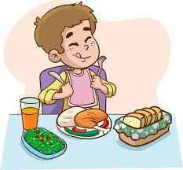Meta niftaħ il-friġġ nara ħafna ikel u xorb. Fil-friġġ ikun hemm ħalib, ilma, meraq tal-laring, ġobon, butir u ġelat. Jien inħobb niekol ħobż bil-butir u l-ġobon.

Fl-armarju hemm għaġin, ħobż, ross, kafè u te. Niekol l-għaġin bit-tadam u l-ġobon. Xi drabi niekol ir-ross bit-tadam, piżelli, fażola u ġobon. Wara l-ikel inħobb niekol ġelat jew frott.

Inħobb nixrob it-te imma fis-sajf nixrob ħafna ilma.

_ _ _ _ _